# **Introduction**

The primary objective of this coursework is to design and implement a comprehensive Gym Management System using the principles of Object-Oriented Programming (OOP) in Java. The project aims to simulate a real-world scenario where a gym manages different types of members—Regular and Premium—through an application that facilitates member registration, attendance tracking, membership activation/deactivation, upgrade eligibility, payment handling, and loyalty management. The system is divided into two key components: the core OOP implementation and a Graphical User Interface (GUI) built using Java’s Abstract Window Toolkit (AWT) and Swing libraries.

At the core of the system lies an abstract class named GymMember, which encapsulates shared member details such as ID, name, contact information, gender, date of birth, membership start date, attendance, loyalty points, and membership status. This class enforces a common structure across all member types while allowing subclass-specific behavior through the use of abstract and inherited methods. Two concrete subclasses, RegularMember and PremiumMember, inherit from GymMember, each adding their own unique features and functionalities. Regular members, for example, have referral sources, attendance limits, and different gym plans (basic, standard, deluxe), while premium members have access to personal trainers and require full or partial payments for their membership with discounts applied upon full payment.

To allow user interaction with the system, a GUI is developed in a separate class named GymGUI. The interface includes labeled text fields for input, combo boxes for plan selection, radio buttons for gender choice, and various buttons to perform specific operations such as adding members, activating or deactivating memberships, marking attendance, upgrading plans, calculating discounts, and handling payments. The GUI not only provides a user-friendly means of accessing the system’s features but also ensures that data is managed consistently and securely using a single ArrayList of GymMember objects, which stores both Regular and Premium members.

Throughout the development process, key OOP principles were applied:

* **Encapsulation** ensured that data fields were protected and accessible only through getters/setters.
* **Inheritance** enabled shared functionality and reusability between the parent and child classes.
* **Abstraction** was used through the abstract mark Attendance() method, enforcing method implementation in the subclasses.
* **Polymorphism** allowed for dynamic behavior, such as calling subclass-specific methods through superclass references during GUI operations.

Robust error handling using try-catch blocks was implemented to manage exceptions, especially during numeric input parsing and file operations. The system also includes features to save member data to a .txt file and retrieve it later, ensuring persistence between sessions.

This report documents every step of the development process in detail. It includes class diagrams, pseudocode for all essential methods, method descriptions, testing evidence (with screenshots), error-handling explanations, and a reflective conclusion. The development and testing were conducted in BlueJ and run via the command prompt, fulfilling all technical requirements as outlined in the coursework brief.

Ultimately, this project serves as a demonstration of how Java OOP and GUI concepts can be applied to solve a realistic, structured problem. It not only strengthens understanding of core programming concepts but also develops practical skills in user interface design, input validation, exception handling, file management, and modular software development.

# **GUI Wireframe**

I used Balsamiq to make wireframes for [project, like an app or website]. Balsamiq was easy to use with its drag-and-drop tools, helping me create simple sketches of how the [app/website] will look and work. These wireframes show the basic layout and main features, making it clear for everyone to understand the plan before building the final design.

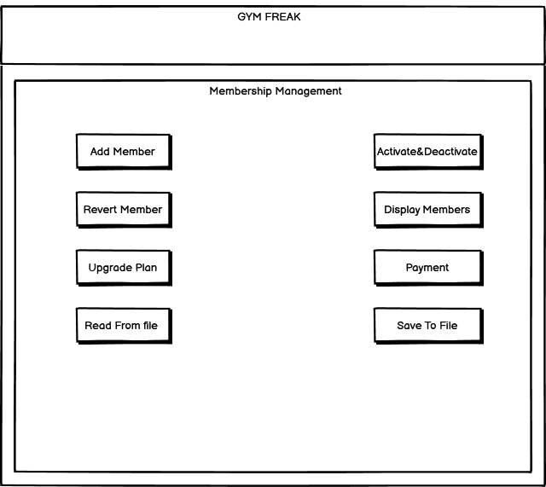

Figure 1: Main Frame

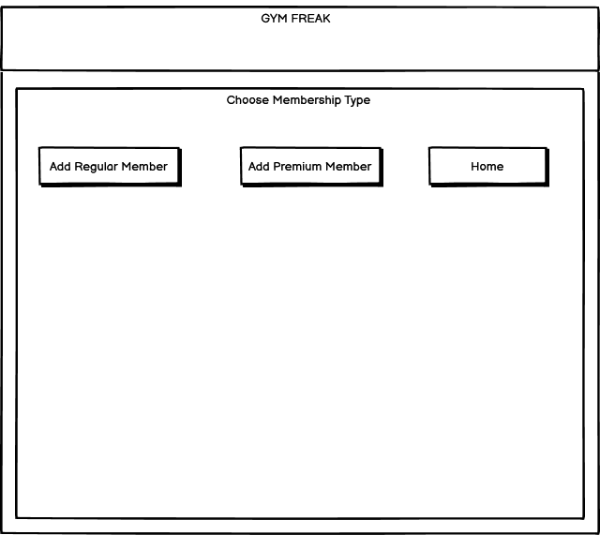

Figure 2: Choose Membership Type

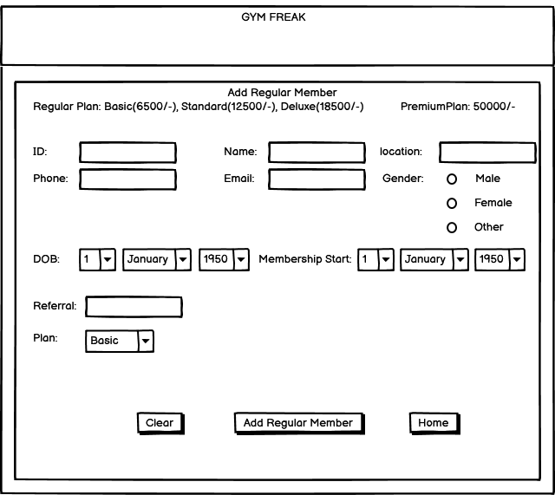

Figure 3: Add Regular Member

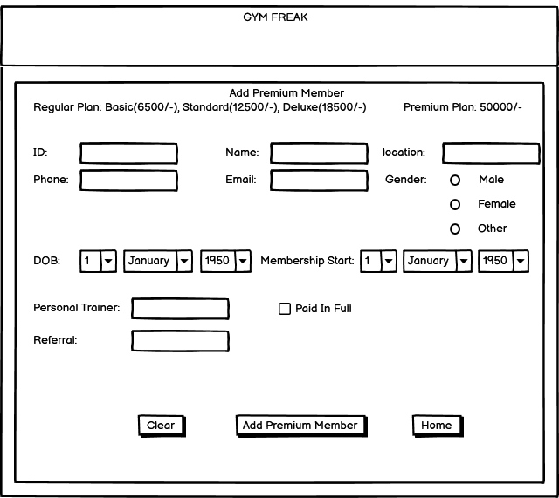

Figure 4: Add Premium Member

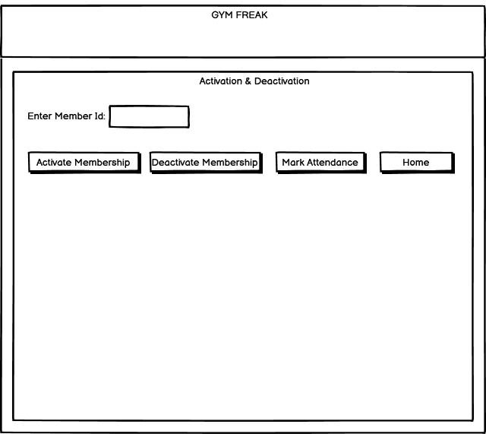

Figure 5: Activation and Deactivation

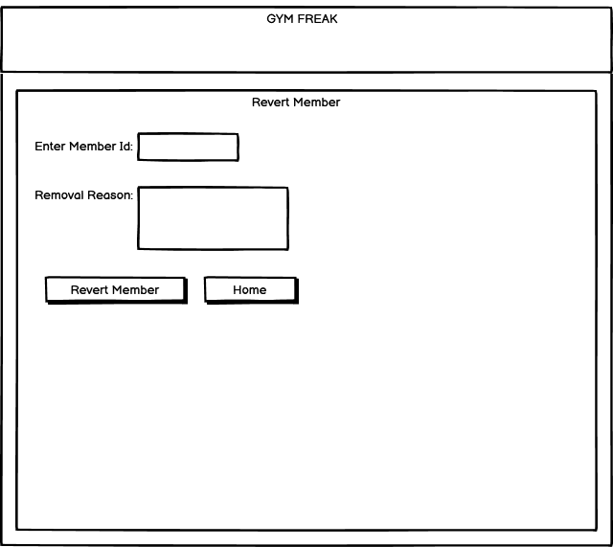

Figure 6: Revert Member

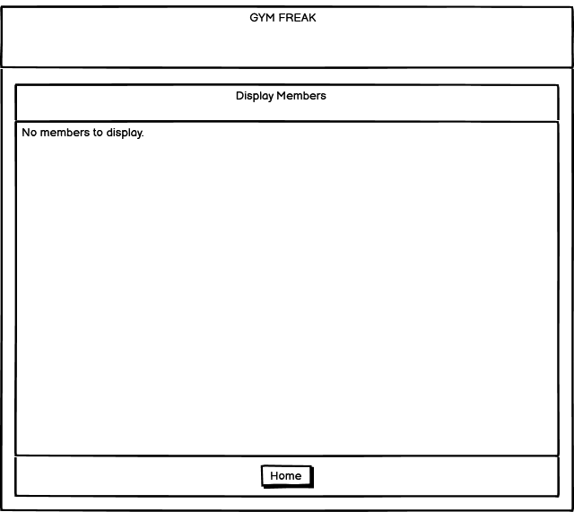

Figure 7: Display Members

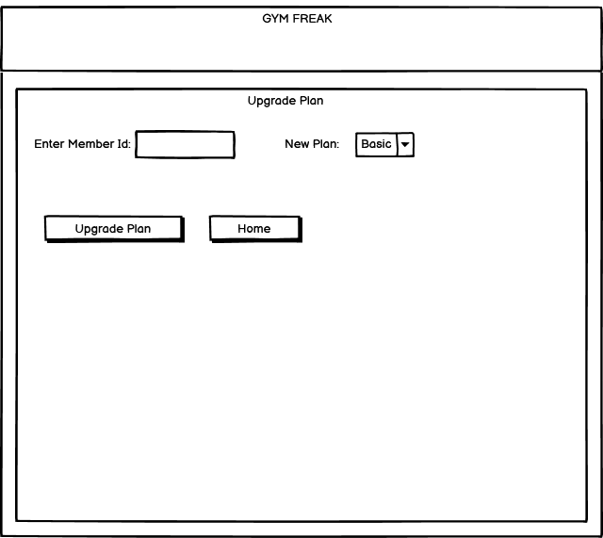

Figure 8: Upgrade Plan

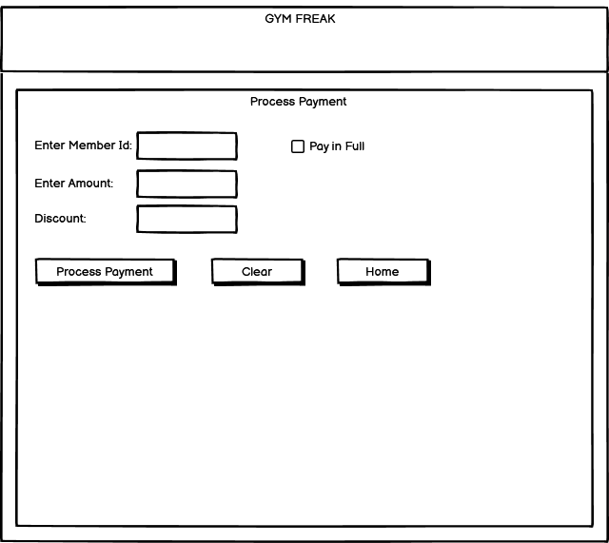

Figure 9: Process Payment

# **Class Diagram**

## Class diagram for GymMember Class

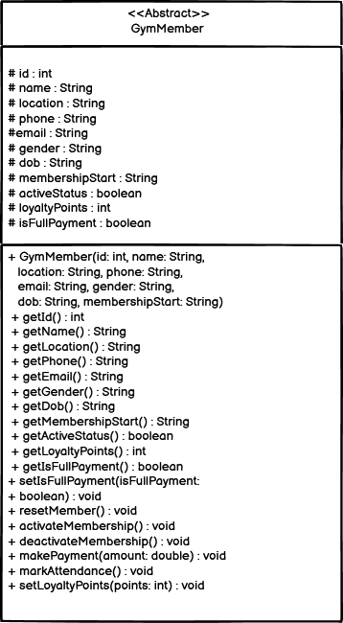

Figure 10: Class diagram for GymMember class

## Class Diagram for RegularMember class

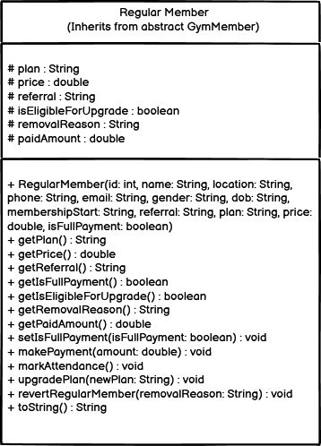

Figure 11: Class diagram for RegularMember class

## Class Diagram for PremiumMember class

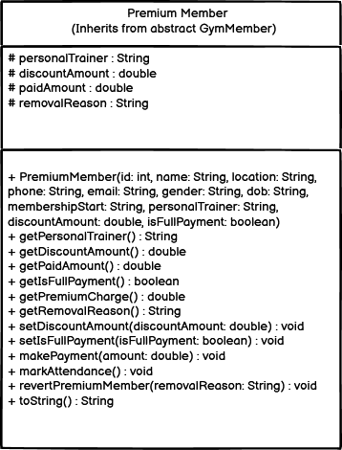

Figure 12: Class diagram for Premium Member class

## Class diagram for GymGUI class

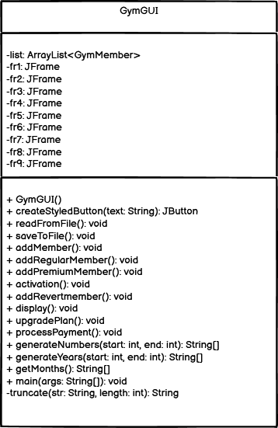

Figure 13: Class diagram for GymGUI class

## Combined class diagram of all class

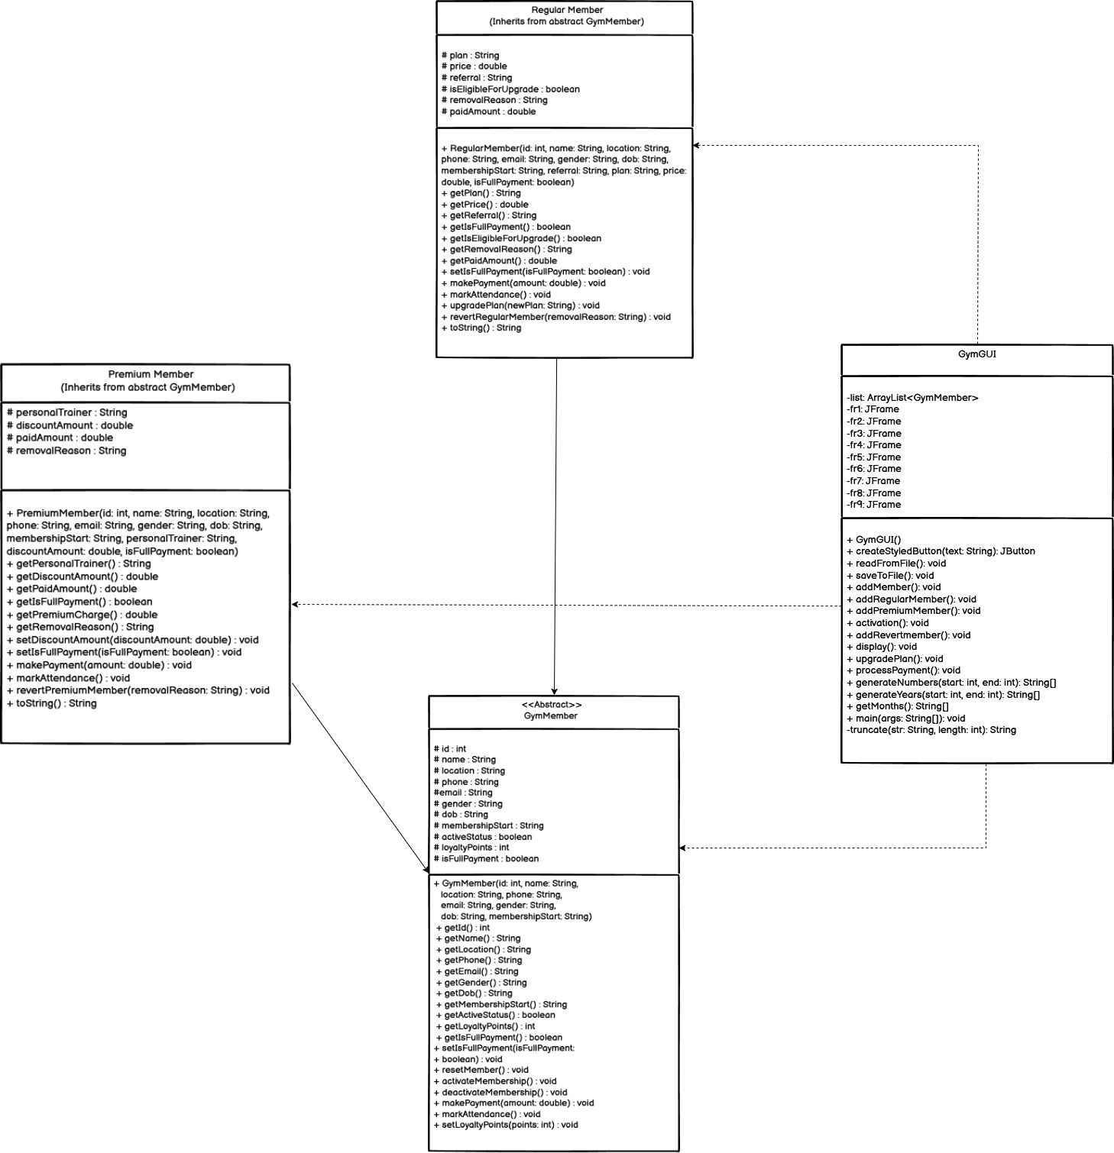

Figure 14: Combined class diagram (Relation)

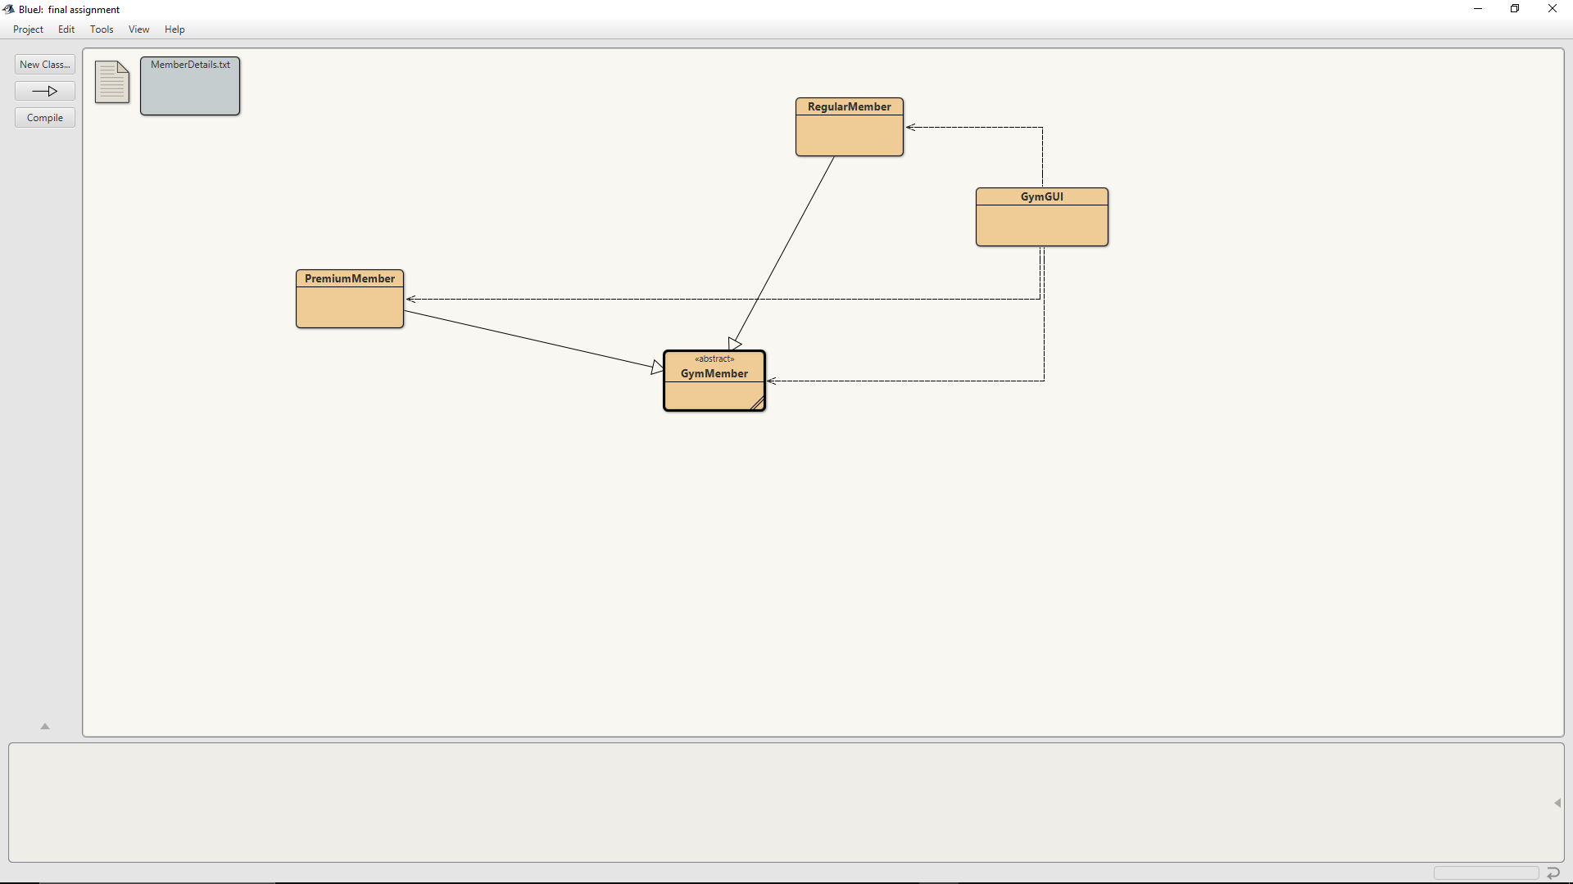

Figure 15: Combined class diagram (actual Relation)

# **Pseudocode**

## Pseudocode for GymMember Class

# Constructor

**START** creating a new GymMember with id, name, location, phone, email, gender, date of birth, membership start date

**ASSIGN** the id to this member's id

**ASSIGN** the name to this member's name

**ASSIGN** the location to this member's location

**ASSIGN** the phone to this member's phone

**ASSIGN** the email to this member's email

**ASSIGN** the gender to this member's gender

**ASSIGN** the date of birth to this member's date of birth

**ASSIGN** the membership start date to this member's membership start date

**SET** this member's active status to false

**SET** this member's loyalty points to 0

**SET** this member's full payment status to false

**FINISH** creating

# resetMember

**BEGIN** resetting the member

**CHANGE** loyalty points to 0

**CHANGE** active status to false

**CHANGE** full payment status to false

**END** resetting

# activateMembership

**START** activating membership

**TURN** active status to true

**FINISH** activating

# deactivateMembership

**BEGIN** deactivating membership

**IF** the member is active THEN

**TURN** active status to false

**ELSE**

**SHOW** message "your membership status is Deactivated."

**END** **IF**

**END** deactivating

# Abstract methods (to be defined in child classes)

**DECLARE** makePayment with amount (to be defined later)

**DECLARE** markAttendance (to be defined later)

## Pseudocode for RegularMember Class

# Pseudocode for RegularMember Class in Plain English

# Constructor

**START** creating RegularMember with id, name, location, phone, email, gender, dob, membershipStart, referral, plan, price, isFullPayment

**CALL** parent constructor with id, name, location, phone, email, gender, dob, membershipStart

**IF** referral is empty or only spaces THEN

SHOW error "Referral cannot be empty."

**END** **IF**

**IF** plan is empty or not "basic", "standard", or "deluxe" THEN

SHOW error "Plan must be basic, standard, or deluxe."

**END** **IF**

**IF** price is not positive THEN

SHOW error "Price must be positive."

**END** **IF**

**SET** plan to lowercase plan

**SET** price to given price

**SET** referral to trimmed referral

**SET** full payment status to isFullPayment

**SET** eligible for upgrade to true

**SET** removal reason to empty

**SET** paid amount to price if isFullPayment is true, else 0

**FINISH** creating

# makePayment

**START** making payment with amount

**IF** amount is negative THEN

**SHOW** error "Payment amount cannot be negative."

**END IF**

**CALCULATE** remaining balance as price minus paid amount

**IF** paid amount plus amount is more than price THEN

SHOW error "Payment exceeds remaining balance of " plus remaining balance

**END IF**

**ADD** amount to paid amount

**IF** paid amount is at least price THEN

**SET** full payment status to true

**END** **IF**

FINISH making

# markAttendance

**START** marking attendance

**IF** membership is active THEN

**ADD** 5 to loyalty points

**ELSE**

**SHOW** error "Cannot mark attendance: Membership is not activated."

**END IF**

**FINISH** marking

# upgradePlan

**START** upgrading plan with newPlan

**IF** newPlan is empty or not "basic", "standard", or "deluxe" THEN

SHOW error "Invalid plan: " plus newPlan

**END IF**

**IF** not eligible for upgrade THEN

**SHOW** error "Member is not eligible for upgrade."

**END IF**

**IF** loyalty points are less than 150 THEN

**SHOW** error "Cannot upgrade: Member must have at least 30 attendances (150 loyalty points). Current points: " plus loyalty points

**END IF**

**SET** plan to lowercase newPlan

**IF** plan is "basic" THEN

**SET** price to 6500

**ELSE IF** plan is "standard" THEN

**SET** price to 12500

**ELSE IF** plan is "deluxe" THEN

**SET** price to 18500

**END IF**

**SET** paid amount to 0

**SET** full payment status to false

**FINISH** upgrading

# revertRegularMember

**START** reverting regular member with removalReason

**IF** removalReason is empty or only spaces THEN

**SHOW** error "Removal reason is required for Regular Members."

**END IF**

**CALL** parent resetMember

**SET** eligible for upgrade to false

**SET** plan to "basic"

**SET** price to 6500

**SET** paid amount to 0

**SET** removal reason to trimmed removalReason

**FINISH** reverting

# toString

**START** converting to string

**CREATE** text builder

**ADD** parent string to text builder

**ADD** newline to text builder

**ADD** "Type: Regular" to text builder

**ADD** newline to text builder

**ADD** "Plan: " plus plan to text builder

**ADD** newline to text builder

**ADD** "Price: " plus price to text builder

**ADD** newline to text builder

**ADD** "Referral: " plus referral to text builder

**ADD** newline to text builder

**ADD** "Paid Amount: " plus paid amount to text builder

**ADD** newline to text builder

**ADD** "Full Payment: " plus "Yes" if full payment, else "No" to text builder

**ADD** newline to text builder

**ADD** "Eligible for Upgrade: " plus "Yes" if eligible for upgrade, else "No" to text builder

**IF** removal reason is not empty THEN

**ADD** newline to text builder

**ADD** "Removal Reason: " plus removal reason to text builder

**END** IF

**RETURN** text builder as string

**FINISH** converting

## Pseudocode for PremiumMember Class

# Constructor

**START** creating a new PremiumMember with id, name, location, phone, email, gender, date of birth, membership start date, personal trainer, discount amount, full payment status

**USE** GymMember's creation with id, name, location, phone, email, gender, date of birth, membership start date

**IF** personal trainer is missing or empty THEN

**SHOW** error "Personal trainer name cannot be empty."

**END IF**

**IF** discount amount is negative or more than premium charge THEN

**SHOW** error "Discount must be between 0 and " plus premium charge

**END IF**

**ASSIGN** trimmed personal trainer to this member's personal trainer

**ASSIGN** discount amount to this member's discount amount

**ASSIGN** paid amount as (premium charge minus discount amount) if full payment is true, otherwise 0

**ASSIGN** full payment status to this member's full payment status

**SET** removal reason to empty

**FINISH** creating

# makePayment

**BEGIN** making payment with amount

**IF** amount is negative THEN

**SHOW** error "Payment amount cannot be negative."

**END IF**

**ADD** amount to paid amount

**CALCULATE** total due as premium charge minus discount amount

**IF** paid amount is at least total due THEN

**TURN** full payment status to true

**END IF**

**END** making payment

# markAttendance

**START** marking attendance

**IF** member is active THEN

**ADD** 10 to loyalty points

**ELSE**

**SHOW** error "Cannot mark attendance: Membership is not activated."

**END IF**

**FINISH** marking attendance

# revertPremiumMember

**START** reverting premium member with removal reason

**IF** removal reason is missing or empty THEN

**SHOW** error "Removal reason is required for Premium Members."

**END IF**

**USE** GymMember's reset

**SET** personal trainer to empty

**TURN** full payment status to false

**SET** paid amount to 0

**SET** discount amount to 0

**ASSIGN** trimmed removal reason to this member's removal reason

**FINISH** reverting

# toString

**BEGIN** creating string description

**GET** GymMember's description

**ADD** newline and "Type: Premium"

**ADD** newline and "Personal Trainer: " plus personal trainer

**ADD** newline and "Discount Amount: " plus discount amount

**ADD** newline and "Paid Amount: " plus paid amount

**ADD** newline and "Full Payment: " plus "Yes" if full payment is true, else "No"

**IF** removal reason is not empty THEN

**ADD** newline and "Removal Reason: " plus removal reason

**END IF**

**RETURN** final description

**END** creating string

## Pseudocode for GymGUI Class

# Pseudocode for GymGUI Class in Plain English

# Constructor

**START** creating GymGUI

**CREATE** a list to store members

**CREATE** main window named "GymFreak"

**SET** main window size to 1400 by 900

**SET** main window layout to none

**MAKE** main window non-resizable

**SET** main window to close program when closed

**SET** main window background to white

**CREATE** header panel

**SET** header panel position to 0, 0, 1400, 80

**SET** header panel background to teal

**SET** header panel layout to none

**ADD** header panel to main window

**CREATE** title label "GymFreak"

**SET** title label position to 580, 15, 240, 50

**SET** title label font to Segoe UI, bold, size 36

**SET** title label color to cyan

**ADD** title label to header panel

**CREATE** subtitle label "Membership Management"

**SET** subtitle label position to 500, 100, 400, 30

**SET** subtitle label font to Segoe UI, bold, size 24

**SET** subtitle label color to cyan

**ADD** subtitle label to main window

**CREATE** Add Member button

**SET** Add Member button position to 250, 200, 300, 60

**WHEN** Add Member button clicked

**CLOSE** main window

**SHOW** add member screen

**END** **WHEN**

**ADD** Add Member button to main window

**CREATE** Activation & Deactivation button

**SET** Activation & Deactivation button position to 850, 200, 300, 60

**WHEN** Activation & Deactivation button clicked

**CLOSE** main window

**SHOW** activation screen

**END** **WHEN**

**ADD** Activation & Deactivation button to main window

**CREATE** Revert Member button

**SET** Revert Member button position to 250, 300, 300, 60

**WHEN** Revert Member button clicked

**CLOSE** main window

**SHOW** revert member screen

**END** **WHEN**

**ADD** Revert Member button to main window

**CREATE** Display Members button

**SET** Display Members button position to 850, 300, 300, 60

**WHEN** Display Members button clicked

**CLOSE** main window

**SHOW** display members screen

**END** **WHEN**

**ADD** Display Members button to main window

**CREATE** Upgrade Plan button

**SET** Upgrade Plan button position to 250, 400, 300, 60

**WHEN** Upgrade Plan button clicked

**CLOSE** main window

**SHOW** upgrade plan screen

**END** **WHEN**

**ADD** Upgrade Plan button to main window

**CREATE** Payment button

**SET** Payment button position to 850, 400, 300, 60

**WHEN** Payment button clicked

**CLOSE** main window

**SHOW** payment screen

**END** **WHEN**

**ADD** Payment button to main window

**CREATE** Read from File button

**SET** Read from File button position to 250, 500, 300, 60

**WHEN** Read from File button clicked

READ from file

**END** **WHEN**

**ADD** Read from File button to main window

**CREATE** Save to File button

**SET** Save to File button position to 850, 500, 300, 60

**WHEN** Save to File button clicked

SAVE to file

**END** **WHEN**

**ADD** Save to File button to main window

**CREATE** main panel

**SET** main panel position to 50, 100, 1300, 750

**SET** main panel background to white

**SET** main panel border to cyan, thickness 1

**SET** main panel layout to none

**ADD** main panel to main window

**SHOW** main window

**FINISH** creating

# createStyledButton

**START** creating styled button with text

**CREATE** button with given text

**SET** button to change background to light cyan on hover, else pale cyan

**SET** button font to Segoe UI, bold, size 20

**SET** button text color to dark blue

**SET** button border to cyan, thickness 1

DISABLE button's default fill

RETURN button

**FINISH** creating

# readFromFile

**START** reading from file

FIND file named "MemberDetails.txt"

**CREATE** display window named "Member Details"

**SET** display window size to 1400 by 900

**SET** display window layout to none

**MAKE** display window non-resizable

**SET** display window to close when closed

**SET** display window background to white

**CREATE** header panel

**SET** header panel position to 0, 0, 1400, 80

**SET** header panel background to teal

**SET** header panel layout to none

**ADD** header panel to display window

**CREATE** title label "GymFreak"

**SET** title label position to 580, 15, 240, 50

**SET** title label font to Segoe UI, bold, size 36

**SET** title label color to cyan

**ADD** title label to header panel

**CREATE** subtitle label "Member Details"

**SET** subtitle label position to 550, 100, 300, 30

**SET** subtitle label font to Segoe UI, bold, size 24

**SET** subtitle label color to cyan

**ADD** subtitle label to display window

**CREATE** text area for display

**SET** text area font to Courier New, plain, size 16

**MAKE** text area non-editable

**SET** text area border to cyan, thickness 1

**TRY**

OPEN file for reading

**CREATE** text builder

READ each line from file

**IF** line exists THEN

**ADD** line with newline to text builder

**END IF**

**CLOSE** file

**IF** text builder is empty THEN

**ADD** "No member details found in the file." to text builder

**END IF**

**SET** text area content to text builder

**CATCH** file error

**SET** text area content to "Error reading file: " plus error message

**END** **TRY**

**CREATE** scroll pane with text area

**SET** scroll pane position to 50, 150, 1300, 650

**SET** scroll pane border to cyan, thickness 1

**ADD** scroll pane to display window

**CREATE** Back button

**SET** Back button position to 600, 820, 200, 40

**SET** Back button font to Segoe UI, bold, size 16

**WHEN** Back button clicked

**CLOSE** display window

**END** **WHEN**

**ADD** Back button to display window

**CREATE** main panel

**SET** main panel position to 50, 100, 1300, 750

**SET** main panel background to white

**SET** main panel border to cyan, thickness 1

**SET** main panel layout to none

**ADD** main panel to display window

**SHOW** display window

**FINISH** reading

# saveToFile

**START** saving to file

FIND file named "MemberDetails.txt"

**TRY**

OPEN file for writing

WRITE header with columns ID, Name, Location, Phone, Email, Membership Start, Plan, Price, Attendance, Loyalty Points, Active Status, Full Payment, Discount Amount, Net Amount Paid

WRITE separator line

**FOR** each member in list

**SET** plan to empty

**SET** price to empty

**SET** attendance to member's loyalty points

**SET** discount amount to "0"

**SET** net amount paid to "0"

**IF** member is RegularMember THEN

**GET** RegularMember details

**SET** plan to member's plan

**SET** price to member's price formatted to 2 decimals

**SET** discount amount to "N/A"

**SET** net amount paid to price if full payment, else "0.00"

**IF** removal reason is not empty THEN

WRITE "Removal Reason: " plus removal reason

**END IF**

**ELSE** **IF** member is PremiumMember THEN

**GET** PremiumMember details

**SET** plan to "Premium"

**SET** price to premium charge formatted to 2 decimals

**SET** discount amount to discount amount formatted to 2 decimals

**SET** net amount paid to paid amount formatted to 2 decimals

**IF** removal reason is not empty THEN

WRITE "Removal Reason: " plus removal reason

**END IF**

**END IF**

WRITE member details formatted with ID, name, location, phone, email, membership start, plan, price, attendance, loyalty points, active status, full payment, discount amount, net amount paid

**END** **FOR**

**CLOSE** file

**SHOW** message "Members saved successfully to MemberDetails.txt"

**CATCH** file error

**SHOW** error message "Error saving file: " plus error message

**END** **TRY**

**FINISH** saving

# addMember

**START** adding member

**CREATE** window named "Add Member"

**SET** window size to 1400 by 900

**SET** window layout to none

**MAKE** window non-resizable

**SET** window to close program when closed

**SET** window background to white

**CREATE** header panel

**SET** header panel position to 0, 0, 1400, 80

**SET** header panel background to teal

**SET** header panel layout to none

**ADD** header panel to window

**CREATE** title label "GymFreak"

**SET** title label position to 580, 15, 240, 50

**SET** title label font to Segoe UI, bold, size 36

**SET** title label color to cyan

**ADD** title label to header panel

**CREATE** subtitle label "Choose Membership Type"

**SET** subtitle label position to 550, 100, 300, 30

**SET** subtitle label font to Segoe UI, bold, size 24

**SET** subtitle label color to cyan

**ADD** subtitle label to window

**CREATE** Add Regular Member button

**SET** Add Regular Member button position to 200, 200, 300, 50

**SET** Add Regular Member button font to Segoe UI, bold, size 16

**WHEN** Add Regular Member button clicked

**CLOSE** window

**SHOW** add regular member screen

**END** **WHEN**

**ADD** Add Regular Member button to window

**CREATE** Add Premium Member button

**SET** Add Premium Member button position to 550, 200, 300, 50

**SET** Add Premium Member button font to Segoe UI, bold, size 16

**WHEN** Add Premium Member button clicked

**CLOSE** window

**SHOW** add premium member screen

**END** **WHEN**

**ADD** Add Premium Member button to window

**CREATE** Home button

**SET** Home button position to 900, 200, 300, 50

**SET** Home button font to Segoe UI, bold, size 16

**WHEN** Home button clicked

**CLOSE** window

**SHOW** main GymGUI screen

**END** **WHEN**

**ADD** Home button to window

**CREATE** main panel

**SET** main panel position to 50, 100, 1300, 750

**SET** main panel background to white

**SET** main panel border to cyan, thickness 1

**SET** main panel layout to none

**ADD** main panel to window

**SHOW** window

**FINISH** adding

# addRegularMember

**START** adding regular member

**CREATE** window named "Add Regular Member"

**SET** window size to 1400 by 900

**SET** window layout to none

**MAKE** window non-resizable

**SET** window to close program when closed

**SET** window background to white

**CREATE** header panel

**SET** header panel position to 0, 0, 1400, 80

**SET** header panel background to teal

**SET** header panel layout to none

**ADD** header panel to window

**CREATE** title label "GymFreak"

**SET** title label position to 580, 15, 240, 50

**SET** title label font to Segoe UI, bold, size 36

**SET** title label color to cyan

**ADD** title label to header panel

**CREATE** subtitle label "Add Regular Member"

**SET** subtitle label position to 550, 100, 300, 30

**SET** subtitle label font to Segoe UI, bold, size 24

**SET** subtitle label color to cyan

**ADD** subtitle label to window

**CREATE** plan prices label "Regular Plans: Basic (6500/-), Standard (12500/-), Deluxe (18500/-)"

**SET** plan prices label position to 200, 140, 800, 30

**SET** plan prices label font to Segoe UI, bold, size 20

**SET** plan prices label color to dark blue

**ADD** plan prices label to window

**CREATE** premium plan label "Premium Plan: 50000/-"

**SET** premium plan label position to 900, 140, 300, 30

**SET** premium plan label font to Segoe UI, bold, size 20

**SET** premium plan label color to dark blue

**ADD** premium plan label to window

**CREATE** ID label "ID:"

**SET** ID label position to 100, 200, 100, 30

**SET** ID label font to Segoe UI, bold, size 20

**ADD** ID label to window

**CREATE** ID text field

**SET** ID text field position to 200, 200, 200, 30

**SET** ID text field font to Segoe UI, plain, size 18

**SET** ID text field border to cyan, thickness 1

**ADD** ID text field to window

**CREATE** Name label "Name:"

**SET** Name label position to 450, 200, 100, 30

**SET** Name label font to Segoe UI, bold, size 20

**ADD** Name label to window

**CREATE** Name text field

**SET** Name text field position to 550, 200, 200, 30

**SET** Name text field font to Segoe UI, plain, size 18

**SET** Name text field border to cyan, thickness 1

**ADD** Name text field to window

**CREATE** Location label "Location:"

**SET** Location label position to 800, 200, 150, 30

**SET** Location label font to Segoe UI, bold, size 20

**ADD** Location label to window

**CREATE** Location text field

**SET** Location text field position to 950, 200, 200, 30

**SET** Location text field font to Segoe UI, plain, size 18

**SET** Location text field border to cyan, thickness 1

**ADD** Location text field to window

**CREATE** Phone label "Phone:"

**SET** Phone label position to 100, 270, 100, 30

**SET** Phone label font to Segoe UI, bold, size 20

**ADD** Phone label to window

**CREATE** Phone text field

**SET** Phone text field position to 200, 270, 200, 30

**SET** Phone text field font to Segoe UI, plain, size 18

**SET** Phone text field border to cyan, thickness 1

**ADD** Phone text field to window

**CREATE** Email label "Email:"

**SET** Email label position to 450, 270, 100, 30

**SET** Email label font to Segoe UI, bold, size 20

**ADD** Email label to window

**CREATE** Email text field

**SET** Email text field position to 550, 270, 200, 30

**SET** Email text field font to Segoe UI, plain, size 18

**SET** Email text field border to cyan, thickness 1

**ADD** Email text field to window

**CREATE** Gender label "Gender:"

**SET** Gender label position to 800, 270, 150, 30

**SET** Gender label font to Segoe UI, bold, size 20

**ADD** Gender label to window

**CREATE** Male radio button "Male"

**SET** Male radio button position to 950, 270, 80, 30

**SET** Male radio button font to Segoe UI, plain, size 18

**SET** Male radio button background to white

**ADD** Male radio button to window

**CREATE** Female radio button "Female"

**SET** Female radio button position to 950, 300, 100, 30

**SET** Female radio button font to Segoe UI, plain, size 18

**SET** Female radio button background to white

**ADD** Female radio button to window

**CREATE** Other radio button "Other"

**SET** Other radio button position to 950, 330, 90, 30

**SET** Other radio button font to Segoe UI, plain, size 18

**SET** Other radio button background to white

**ADD** Other radio button to window

**CREATE** gender group

**ADD** Male, Female, Other radio buttons to gender group

**CREATE** DOB label "DOB:"

**SET** DOB label position to 100, 380, 100, 30

**SET** DOB label font to Segoe UI, bold, size 20

**ADD** DOB label to window

**CREATE** DOB day dropdown with numbers 1 to 31

**SET** DOB day dropdown position to 200, 380, 60, 30

**SET** DOB day dropdown font to Segoe UI, plain, size 18

**ADD** DOB day dropdown to window

**CREATE** DOB month dropdown with months

**SET** DOB month dropdown position to 280, 380, 100, 30

**SET** DOB month dropdown font to Segoe UI, plain, size 18

**ADD** DOB month dropdown to window

**CREATE** DOB year dropdown with years 1950 to 2025

**SET** DOB year dropdown position to 400, 380, 100, 30

**SET** DOB year dropdown font to Segoe UI, plain, size 18

**ADD** DOB year dropdown to window

**CREATE** Membership Start label "Membership Start:"

**SET** Membership Start label position to 550, 380, 200, 30

**SET** Membership Start label font to Segoe UI, bold, size 20

**ADD** Membership Start label to window

**CREATE** Membership Start day dropdown with numbers 1 to 31

**SET** Membership Start day dropdown position to 750, 380, 60, 30

**SET** Membership Start day dropdown font to Segoe UI, plain, size 18

**ADD** Membership Start day dropdown to window

**CREATE** Membership Start month dropdown with months

**SET** Membership Start month dropdown position to 830, 380, 100, 30

**SET** Membership Start month dropdown font to Segoe UI, plain, size 18

**ADD** Membership Start month dropdown to window

**CREATE** Membership Start year dropdown with years 2023 to 2025

**SET** Membership Start year dropdown position to 950, 380, 100, 30

**SET** Membership Start year dropdown font to Segoe UI, plain, size 18

**ADD** Membership Start year dropdown to window

**CREATE** Referral label "Referral:"

**SET** Referral label position to 100, 450, 100, 30

**SET** Referral label font to Segoe UI, bold, size 20

**ADD** Referral label to window

**CREATE** Referral text field

**SET** Referral text field position to 200, 450, 200, 30

**SET** Referral text field font to Segoe UI, plain, size 18

**SET** Referral text field border to cyan, thickness 1

**ADD** Referral text field to window

**CREATE** Removal Reason label "Removal Reason:"

**SET** Removal Reason label position to 450, 450, 200, 30

**SET** Removal Reason label font to Segoe UI, bold, size 20

**ADD** Removal Reason label to window

**CREATE** Removal Reason text area

**SET** Removal Reason text area position to 650, 450, 200, 60

**SET** Removal Reason text area font to Segoe UI, plain, size 18

**SET** Removal Reason text area border to cyan, thickness 1

**ADD** Removal Reason text area to window

**CREATE** Plan label "Plan:"

**SET** Plan label position to 100, 520, 100, 30

**SET** Plan label font to Segoe UI, bold, size 20

**ADD** Plan label to window

**CREATE** Plan dropdown with options "basic", "standard", "deluxe"

**SET** Plan dropdown position to 200, 520, 200, 30

**SET** Plan dropdown font to Segoe UI, plain, size 18

**ADD** Plan dropdown to window

**CREATE** Clear button

**SET** Clear button position to 355, 650, 200, 40

**SET** Clear button font to Segoe UI, bold, size 16

**WHEN** Clear button clicked

**CLEAR** ID text field

**CLEAR** Name text field

**CLEAR** Location text field

**CLEAR** Phone text field

**CLEAR** Email text field

**CLEAR** Referral text field

**CLEAR** Removal Reason text area

RE**SET** DOB day dropdown to first option

RE**SET** DOB month dropdown to first option

RE**SET** DOB year dropdown to first option

RE**SET** Membership Start day dropdown to first option

RE**SET** Membership Start month dropdown to first option

RE**SET** Membership Start year dropdown to first option

RE**SET** Plan dropdown to first option

**CLEAR** gender selection

**END** **WHEN**

**ADD** Clear button to window

**CREATE** Add Regular Member button

**SET** Add Regular Member button position to 575, 650, 200, 40

**SET** Add Regular Member button font to Segoe UI, bold, size 16

**WHEN** Add Regular Member button clicked

**TRY**

**GET** ID from ID text field

**GET** name from Name text field

**GET** location from Location text field

**GET** phone from Phone text field

**GET** email from Email text field

**GET** referral from Referral text field

**GET** removal reason from Removal Reason text area

**GET** plan from Plan dropdown

**GET** full payment status from checkbox

**IF** ID is empty THEN

**SHOW** error "ID cannot be empty."

**END IF**

**CONVERT** ID to number

**IF** ID is not a number THEN

**SHOW** error "ID must be a numeric value."

**END IF**

**IF** ID is not positive THEN

**SHOW** error "ID must be a positive number."

**END IF**

**FOR** each member in list

**IF** member ID equals ID THEN

**SHOW** error "Member ID already exists."

**END IF**

**END** **FOR**

**IF** name is empty or contains non-letters THEN

**SHOW** error "Name must contain letters only."

**END IF**

**IF** phone is empty or not 10 digits THEN

**SHOW** error "Phone must be a 10-digit number."

**END IF**

**IF** location is empty THEN

**SHOW** error "Location cannot be empty."

**END IF**

**IF** email is empty or invalid format THEN

**SHOW** error "Invalid email format."

**END IF**

**IF** referral is empty THEN

**SHOW** error "Referral source cannot be empty."

**END IF**

**IF** plan is not selected THEN

**SHOW** error "Please select a plan."

**END IF**

**GET** gender from radio buttons

**IF** gender is not selected THEN

**SHOW** error "Please select a gender."

**END IF**

**IF** DOB day, month, or year is not selected THEN

**SHOW** error "Please select a valid date of birth."

**END IF**

COMBINE DOB as day, month, year

**IF** Membership Start day, month, or year is not selected THEN

**SHOW** error "Please select a valid membership start date."

**END IF**

COMBINE Membership Start as day, month, year

**SET** price based on plan

**IF** plan is "basic" THEN

**SET** price to 6500

**ELSE** **IF** plan is "standard" THEN

**SET** price to 12500

**ELSE** **IF** plan is "deluxe" THEN

**SET** price to 18500

**ELSE**

**SHOW** error "Invalid plan selected."

**END IF**

**CREATE** new RegularMember with ID, name, location, phone, email, gender, DOB, Membership Start, referral, plan, price, full payment

**IF** full payment is true THEN

**PROCESS** payment of price

**END IF**

**ADD** RegularMember to list

**SHOW** message "Regular Member added successfully! Price: " plus price

**TRIGGER** Clear button

**CATCH** input error

**SHOW** error message with error details

**CATCH** any error

**SHOW** error message "Unexpected error occurred: " plus error details

**END** **TRY**

**END** **WHEN**

**ADD** Add Regular Member button to window

**CREATE** Home button

**SET** Home button position to 795, 650, 200, 40

**SET** Home button font to Segoe UI, bold, size 16

**WHEN** Home button clicked

**CLOSE** window

**SHOW** main GymGUI screen

**END** **WHEN**

**ADD** Home button to window

**CREATE** main panel

**SET** main panel position to 50, 100, 1300, 750

**SET** main panel background to white

**SET** main panel border to cyan, thickness 1

**SET** main panel layout to none

**ADD** main panel to window

**SHOW** window

**FINISH** adding

# addPremiumMember

**START** adding premium member

**CREATE** window named "Add Premium Member"

**SET** window size to 1400 by 900

**SET** window layout to none

**MAKE** window non-resizable

**SET** window to close program when closed

**SET** window background to white

**CREATE** header panel

**SET** header panel position to 0, 0, 1400, 80

**SET** header panel background to teal

**SET** header panel layout to none

**ADD** header panel to window

**CREATE** title label "GymFreak"

**SET** title label position to 580, 15, 240, 50

**SET** title label font to Segoe UI, bold, size 36

**SET** title label color to cyan

**ADD** title label to header panel

**CREATE** subtitle label "Add Premium Member"

**SET** subtitle label position to 550, 100, 300, 30

**SET** subtitle label font to Segoe UI, bold, size 24

**SET** subtitle label color to cyan

**ADD** subtitle label to window

**CREATE** plan prices label "Regular Plans: Basic (6500/-), Standard (12500/-), Deluxe (18500/-)"

**SET** plan prices label position to 200, 140, 800, 30

**SET** plan prices label font to Segoe UI, bold, size 20

**SET** plan prices label color to dark blue

**ADD** plan prices label to window

**CREATE** premium plan label "Premium Plan: 50000/-"

**SET** premium plan label position to 900, 140, 300, 30

**SET** premium plan label font to Segoe UI, bold, size 20

**SET** premium plan label color to dark blue

**ADD** premium plan label to window

**CREATE** ID label "ID:"

**SET** ID label position to 100, 200, 100, 30

**SET** ID label font to Segoe UI, bold, size 20

**ADD** ID label to window

**CREATE** ID text field

**SET** ID text field position to 200, 200, 200, 30

**SET** ID text field font to Segoe UI, plain, size 18

**SET** ID text field border to cyan, thickness 1

**ADD** ID text field to window

**CREATE** Name label "Name:"

**SET** Name label position to 450, 200, 100, 30

**SET** Name label font to Segoe UI, bold, size 20

**ADD** Name label to window

**CREATE** Name text field

**SET** Name text field position to 550, 200, 200, 30

**SET** Name text field font to Segoe UI, plain, size 18

**SET** Name text field border to cyan, thickness 1

**ADD** Name text field to window

**CREATE** Location label "Location:"

**SET** Location label position to 800, 200, 150, 30

**SET** Location label font to Segoe UI, bold, size 20

**ADD** Location label to window

**CREATE** Location text field

**SET** Location text field position to 950, 200, 200, 30

**SET** Location text field font to Segoe UI, plain, size 18

**SET** Location text field border to cyan, thickness 1

**ADD** Location text field to window

**CREATE** Phone label "Phone:"

**SET** Phone label position to 100, 270, 100, 30

**SET** Phone label font to Segoe UI, bold, size 20

**ADD** Phone label to window

**CREATE** Phone text field

**SET** Phone text field position to 200, 270, 200, 30

**SET** Phone text field font to Segoe UI, plain, size 18

**SET** Phone text field border to cyan, thickness 1

**ADD** Phone text field to window

**CREATE** Email label "Email:"

**SET** Email label position to 450, 270, 100, 30

**SET** Email label font to Segoe UI, bold, size 20

**ADD** Email label to window

**CREATE** Email text field

**SET** Email text field position to 550, 270, 200, 30

**SET** Email text field font to Segoe UI, plain, size 18

**SET** Email text field border to cyan, thickness 1

**ADD** Email text field to window

**CREATE** Gender label "Gender:"

**SET** Gender label position to 800, 270, 150, 30

**SET** Gender label font to Segoe UI, bold, size 20

**ADD** Gender label to window

**CREATE** Male radio button "Male"

**SET** Male radio button position to 950, 270, 80, 30

**SET** Male radio button font to Segoe UI, plain, size 18

**SET** Male radio button background to white

**ADD** Male radio button to window

**CREATE** Female radio button "Female"

**SET** Female radio button position to 950, 300, 100, 30

**SET** Female radio button font to Segoe UI, plain, size 18

**SET** Female radio button background to white

**ADD** Female radio button to window

**CREATE** Other radio button "Other"

**SET** Other radio button position to 950, 330, 90, 30

**SET** Other radio button font to Segoe UI, plain, size 18

**SET** Other radio button background to white

**ADD** Other radio button to window

**CREATE** gender group

**ADD** Male, Female, Other radio buttons to gender group

**CREATE** DOB label "DOB:"

**SET** DOB label position to 100, 380, 100, 30

**SET** DOB label font to Segoe UI, bold, size 20

**ADD** DOB label to window

**CREATE** DOB day dropdown with numbers 1 to 31

**SET** DOB day dropdown position to 200, 380, 60, 30

**SET** DOB day dropdown font to Segoe UI, plain, size 18

**ADD** DOB day dropdown to window

**CREATE** DOB month dropdown with months

**SET** DOB month dropdown position to 280, 380, 100, 30

**SET** DOB month dropdown font to Segoe UI, plain, size 18

**ADD** DOB month dropdown to window

**CREATE** DOB year dropdown with years 1950 to 2025

**SET** DOB year dropdown position to 400, 380, 100, 30

**SET** DOB year dropdown font to Segoe UI, plain, size 18

**ADD** DOB year dropdown to window

**CREATE** Membership Start label "Membership Start:"

**SET** Membership Start label position to 550, 380, 200, 30

**SET** Membership Start label font to Segoe UI, bold, size 20

**ADD** Membership Start label to window

**CREATE** Membership Start day dropdown with numbers 1 to 31

**SET** Membership Start day dropdown position to 750, 380, 60, 30

**SET** Membership Start day dropdown font to Segoe UI, plain, size 18

**ADD** Membership Start day dropdown to window

**CREATE** Membership Start month dropdown with months

**SET** Membership Start month dropdown position to 830, 380, 100, 30

**SET** Membership Start month dropdown font to Segoe UI, plain, size 18

**ADD** Membership Start month dropdown to window

**CREATE** Membership Start year dropdown with years 2023 to 2025

**SET** Membership Start year dropdown position to 950, 380, 100, 30

**SET** Membership Start year dropdown font to Segoe UI, plain, size 18

**ADD** Membership Start year dropdown to window

**CREATE** Personal Trainer label "Personal Trainer:"

**SET** Personal Trainer label position to 100, 450, 200, 30

**SET** Personal Trainer label font to Segoe UI, bold, size 20

**ADD** Personal Trainer label to window

**CREATE** Personal Trainer text field

**SET** Personal Trainer text field position to 300, 450, 200, 30

**SET** Personal Trainer text field font to Segoe UI, plain, size 18

**SET** Personal Trainer text field border to cyan, thickness 1

**ADD** Personal Trainer text field to window

**CREATE** Paid in Full checkbox "Paid in Full"

**SET** Paid in Full checkbox position to 950, 450, 150, 30

**SET** Paid in Full checkbox font to Segoe UI, plain, size 18

**SET** Paid in Full checkbox background to white

**ADD** Paid in Full checkbox to window

**CREATE** Clear button

**SET** Clear button position to 355, 650, 200, 40

**SET** Clear button font to Segoe UI, bold, size 16

**WHEN** Clear button clicked

**CLEAR** ID text field

**CLEAR** Name text field

**CLEAR** Location text field

**CLEAR** Phone text field

**CLEAR** Email text field

**CLEAR** Personal Trainer text field

**SET** Discount text field to "0"

UNCHECK Paid in Full checkbox

RE**SET** DOB day dropdown to first option

RE**SET** DOB month dropdown to first option

RE**SET** DOB year dropdown to first option

RE**SET** Membership Start day dropdown to first option

RE**SET** Membership Start month dropdown to first option

RE**SET** Membership Start year dropdown to first option

**CLEAR** gender selection

**END** **WHEN**

**ADD** Clear button to window

**CREATE** Add Premium Member button

**SET** Add Premium Member button position to 575, 650, 200, 40

**SET** Add Premium Member button font to Segoe UI, bold, size 16

**WHEN** Add Premium Member button clicked

**TRY**

**GET** ID from ID text field

**GET** name from Name text field

**GET** location from Location text field

**GET** phone from Phone text field

**GET** email from Email text field

**GET** personal trainer from Personal Trainer text field

**GET** discount from Discount text field

**GET** full payment status from checkbox

**IF** ID is empty THEN

**SHOW** error "ID cannot be empty."

**END IF**

**CONVERT** ID to number

**IF** ID is not a number THEN

**SHOW** error "ID must be a numeric value."

**END IF**

**IF** ID is not positive THEN

**SHOW** error "ID must be a positive number."

**END IF**

**FOR** each member in list

**IF** member ID equals ID THEN

**SHOW** error "Member ID already exists."

**END IF**

**END** **FOR**

**IF** name is empty or contains non-letters THEN

**SHOW** error "Name must contain letters only."

**END IF**

**IF** phone is empty or not 10 digits THEN

**SHOW** error "Phone must be a 10-digit number."

**END IF**

**IF** location is empty THEN

**SHOW** error "Location cannot be empty."

**END IF**

**IF** email is empty or invalid format THEN

**SHOW** error "Invalid email format."

**END IF**

**IF** personal trainer is empty THEN

**SHOW** error "Personal trainer name cannot be empty."

**END IF**

**SET** discount amount to 0 if discount is empty

**CONVERT** discount to number

**IF** discount is not a number THEN

**SHOW** error "Discount must be a valid number."

**END IF**

**IF** discount is negative or more than 50000 THEN

**SHOW** error "Discount must be between 0 and 50000."

**END IF**

**GET** gender from radio buttons

**IF** gender is not selected THEN

**SHOW** error "Please select a gender."

**END IF**

**IF** DOB day, month, or year is not selected THEN

**SHOW** error "Please select a valid date of birth."

**END IF**

COMBINE DOB as day, month, year

**IF** Membership Start day, month, or year is not selected THEN

**SHOW** error "Please select a valid membership start date."

**END IF**

COMBINE Membership Start as day, month, year

**CREATE** new PremiumMember with ID, name, location, phone, email, gender, DOB, Membership Start, personal trainer, discount amount, full payment

**ADD** PremiumMember to list

**CALCULATE** amount due as 50000 minus discount amount

**SHOW** message "Premium Member added successfully! Amount Due: " plus amount due plus " (Paid in Full)" if full payment is true

**TRIGGER** Clear button

**CATCH** input error

**SHOW** error message with error details

**CATCH** any error

**SHOW** error message "Unexpected error occurred: " plus error details

**END** **TRY**

**END** **WHEN**

**ADD** Add Premium Member button to window

**CREATE** Home button

**SET** Home button position to 795, 650, 200, 40

**SET** Home button font to Segoe UI, bold, size 16

**WHEN** Home button clicked

**CLOSE** window

**SHOW** main GymGUI screen

**END** **WHEN**

**ADD** Home button to window

**CREATE** main panel

**SET** main panel position to 50, 100, 1300, 750

**SET** main panel background to white

**SET** main panel border to cyan, thickness 1

**SET** main panel layout to none

**ADD** main panel to window

**SHOW** window

**FINISH** adding

# activation

**START** managing activation

**CREATE** window named "Activation & Deactivation"

**SET** window size to 1400 by 900

**SET** window layout to none

**MAKE** window non-resizable

**SET** window to close program when closed

**SET** window background to white

**CREATE** header panel

**SET** header panel position to 0, 0, 1400, 80

**SET** header panel background to teal

**SET** header panel layout to none

**ADD** header panel to window

**CREATE** title label "GymFreak"

**SET** title label position to 580, 15, 240, 50

**SET** title label font to Segoe UI, bold, size 36

**SET** title label color to cyan

**ADD** title label to header panel

**CREATE** subtitle label "Activation & Deactivation"

**SET** subtitle label position to 550, 100, 300, 30

**SET** subtitle label font to Segoe UI, bold, size 24

**SET** subtitle label color to cyan

**ADD** subtitle label to window

**CREATE** ID label "Enter Member ID:"

**SET** ID label position to 50, 190, 150, 30

**SET** ID label font to Segoe UI, bold, size 20

**ADD** ID label to window

**CREATE** ID text field

**SET** ID text field position to 200, 190, 200, 30

**SET** ID text field font to Segoe UI, plain, size 18

**SET** ID text field border to cyan, thickness 1

**ADD** ID text field to window

**CREATE** Activate Membership button

**SET** Activate Membership button position to 200, 240, 200, 40

**SET** Activate Membership button font to Segoe UI, bold, size 16

**WHEN** Activate Membership button clicked

**TRY**

**GET** ID from ID text field

**IF** ID is empty THEN

**SHOW** error "ID cannot be empty."

**END IF**

**CONVERT** ID to number

**IF** ID is not a number THEN

**SHOW** error "ID must be a numeric value."

**END IF**

**IF** ID is not positive THEN

**SHOW** error "ID must be a positive number."

**END IF**

**SET** target member to none

**FOR** each member in list

**IF** member ID equals ID THEN

**SET** target member to member

**BREAK**

**END IF**

**END** **FOR**

**IF** target member is none THEN

**SHOW** error "Member ID not found."

**END IF**

**IF** target member is active THEN

**SHOW** error "Membership is already active."

**END IF**

ACTIVATE target member's membership

**SHOW** message "Membership activated successfully!"

**CLEAR** ID text field

**CATCH** input error

**SHOW** error message with error details

**CATCH** state error

**SHOW** error message with error details

**CATCH** any error

**SHOW** error message "Unexpected error occurred: " plus error details

**END** **TRY**

**END** **WHEN**

**ADD** Activate Membership button to window

**CREATE** Deactivate Membership button

**SET** Deactivate Membership button position to 450, 240, 200, 40

**SET** Deactivate Membership button font to Segoe UI, bold, size 16

**WHEN** Deactivate Membership button clicked

**TRY**

**GET** ID from ID text field

**IF** ID is empty THEN

**SHOW** error "ID cannot be empty."

**END IF**

**CONVERT** ID to number

**IF** ID is not a number THEN

**SHOW** error "ID must be a numeric value."

**END IF**

**IF** ID is not positive THEN

**SHOW** error "ID must be a positive number."

**END IF**

**SET** target member to none

**FOR** each member in list

**IF** member ID equals ID THEN

**SET** target member to member

**BREAK**

**END IF**

**END** **FOR**

**IF** target member is none THEN

**SHOW** error "Member ID not found."

**END IF**

**IF** target member is not active THEN

**SHOW** error "Membership is already deactivated."

**END IF**

**DEACTIVATE** target member's membership

**SHOW** message "Membership deactivated successfully!"

**CLEAR** ID text field

**CATCH** input error

**SHOW** |state error

**SHOW** error message with error details

**CATCH** any error

**SHOW** error message "Unexpected error occurred: " plus error details

**END** **TRY**

**END** **WHEN**

**ADD** Deactivate Membership button to window

**CREATE** Mark Attendance button

**SET** Mark Attendance button position to 700, 240, 200, 40

**SET** Mark Attendance button font to Segoe UI, bold, size 16

**WHEN** Mark Attendance button clicked

**TRY**

**GET** ID from ID text field

**IF** ID is empty THEN

**SHOW** error "ID cannot be empty."

**END IF**

**CONVERT** ID to number

**IF** ID is not a number THEN

**SHOW** error "ID must be a numeric value."

**END IF**

**IF** ID is not positive THEN

**SHOW** error "ID must be a positive number."

**END IF**

**SET** target member to none

**FOR** each member in list

**IF** member ID equals ID THEN

**SET** target member to member

**BREAK**

**END IF**

**END** **FOR**

**IF** target member is none THEN

**SHOW** error "Member ID not found."

**END IF**

MARK target member's attendance

**SET** member type to "Regular" if target member is RegularMember, else "Premium"

**SHOW** message "Attendance marked for " plus member type plus " Member! Loyalty Points: " plus target member's loyalty points

**CLEAR** ID text field

**CATCH** input error

**SHOW** error message with error details

**CATCH** state error

**SHOW** error message "Cannot mark attendance: Membership is not activated."

**CATCH** any error

**SHOW** error message "Unexpected error occurred: " plus error details

**END** **TRY**

**END** **WHEN**

**ADD** Mark Attendance button to window

**CREATE** Home button

**SET** Home button position to 950, 240, 200, 40

**SET** Home button font to Segoe UI, bold, size 16

**WHEN** Home button clicked

**CLOSE** window

**SHOW** main GymGUI screen

**END** **WHEN**

**ADD** Home button to window

**CREATE** main panel

**SET** main panel position to 50, 100, 1300, 750

**SET** main panel background to white

**SET** main panel border to cyan, thickness 1

**SET** main panel layout to none

**ADD** main panel to window

**SHOW** window

**FINISH** managing

# addRevertmember

**START** reverting member

**CREATE** window named "Revert Member"

**SET** window size to 1400 by 900

**SET** window layout to none

**MAKE** window non-resizable

**SET** window to close program when closed

**SET** window background to white

**CREATE** header panel

**SET** header panel position to 0, 0, 1400, 80

**SET** header panel background to teal

**SET** header panel layout to none

**ADD** header panel to window

**CREATE** title label "GymFreak"

**SET** title label position to 580, 15, 240, 50

**SET** title label font to Segoe UI, bold, size 36

**SET** title label color to cyan

**ADD** title label to header panel

**CREATE** subtitle label "Revert Member"

**SET** subtitle label position to 550, 100, 300, 30

**SET** subtitle label font to Segoe UI, bold, size 24

**SET** subtitle label color to cyan

**ADD** subtitle label to window

**CREATE** ID label "Enter Member ID:"

**SET** ID label position to 50, 190, 150, 30

**SET** ID label font to Segoe UI, bold, size 20

**ADD** ID label to window

**CREATE** ID text field

**SET** ID text field position to 200, 190, 300, 30

**SET** ID text field font to Segoe UI, plain, size 18

**SET** ID text field border to cyan, thickness 1

**ADD** ID text field to window

**CREATE** Removal Reason label "Removal Reason:"

**SET** Removal Reason label position to 50, 240, 250, 30

**SET** Removal Reason label font to Segoe UI, bold, size 20

**ADD** Removal Reason label to window

**CREATE** Removal Reason text area

**SET** Removal Reason text area font to Segoe UI, plain, size 18

**ENABLE** text wrapping for Removal Reason text area

**SET** Removal Reason text area position to 300, 240, 300, 60

**SET** Removal Reason text area border to cyan, thickness 1

**CREATE** scroll pane for Removal Reason text area

**SET** scroll pane position to 300, 240, 300, 60

**SET** scroll pane border to cyan, thickness 1

**ADD** scroll pane to window

**CREATE** note label "Required for all members"

**SET** note label position to 300, 300, 300, 20

**SET** note label font to Segoe UI, italic, size 14

**SET** note label color to dark blue

**ADD** note label to window

**CREATE** Revert Member button

**SET** Revert Member button position to 200, 330, 200, 40

**SET** Revert Member button font to Arial, bold, size 16

**WHEN** Revert Member button clicked

**TRY**

**GET** ID from ID text field

**GET** removal reason from Removal Reason text area

**IF** ID is empty THEN

**SHOW** error "ID cannot be empty."

**END IF**

**CONVERT** ID to number

**IF** ID is not a number THEN

**SHOW** error "ID must be a numeric value."

**END IF**

**IF** ID is not positive THEN

**SHOW** error "ID must be a positive number."

**END IF**

**IF** removal reason is empty THEN

**SHOW** error "Removal reason is required for all members."

**END IF**

**SET** target member to none

**FOR** each member in list

**IF** member ID equals ID THEN

**SET** target member to member

**BREAK**

**END IF**

**END** **FOR**

**IF** target member is none THEN

**SHOW** error "Member ID not found."

**END IF**

**IF** target member is RegularMember THEN

REVERT RegularMember with removal reason

**SHOW** message "Regular Member reverted successfully! Plan set to basic, reason: " plus removal reason

**ELSE** **IF** target member is PremiumMember THEN

REVERT PremiumMember with removal reason

**SHOW** message "Premium Member reverted successfully! Trainer and payments cleared, reason: " plus removal reason

**END IF**

**CLEAR** ID text field

**CLEAR** Removal Reason text area

**CATCH** input error

**SHOW** error message with error details

**CATCH** any error

**SHOW** error message "Unexpected error occurred: " plus error details

**END** **TRY**

**END** **WHEN**

**ADD** Revert Member button to window

**CREATE** Home button

**SET** Home button position to 450, 330, 200, 40

**SET** Home button font to Segoe UI, bold, size 16

**WHEN** Home button clicked

**CLOSE** window

**SHOW** main GymGUI screen

**END** **WHEN**

**ADD** Home button to window

**CREATE** main panel

**SET** main panel position to 50, 100, 1300, 750

**SET** main panel background to white

**SET** main panel border to cyan, thickness 1

**SET** main panel layout to none

**ADD** main panel to window

**SHOW** window

**FINISH** reverting

# display

**START** displaying members

**CREATE** window named "Display Members"

**SET** window size to 1400 by 900

**SET** window layout to none

**MAKE** window non-resizable

**SET** window to close program when closed

**SET** window background to white

**CREATE** header panel

**SET** header panel position to 0, 0, 1400, 80

**SET** header panel background to teal

**SET** header panel layout to none

**ADD** header panel to window

**CREATE** title label "GymFreak"

**SET** title label position to 580, 15, 240, 50

**SET** title label font to Segoe UI, bold, size 36

**SET** title label color to cyan

**ADD** title label to header panel

**CREATE** subtitle label "Display Members"

**SET** subtitle label position to 550, 100, 300, 30

**SET** subtitle label font to Segoe UI, bold, size 24

**SET** subtitle label color to cyan

**ADD** subtitle label to window

**CREATE** text area for display

**SET** text area font to Segoe UI, plain, size 18

**MAKE** text area non-editable

**SET** text area border to cyan, thickness 1

**TRY**

**CREATE** text builder

**IF** list is empty THEN

**ADD** "No members to display." to text builder

**ELSE**

**FOR** each member in list

**IF** member is null THEN

SKIP to next member

**END IF**

**ADD** "ID: " plus member ID to text builder

**ADD** "Name: " plus member name or "N/A" if null to text builder

**ADD** "Location: " plus member location or "N/A" if null to text builder

**ADD** "Phone: " plus member phone or "N/A" if null to text builder

**ADD** "Email: " plus member email or "N/A" if null to text builder

**ADD** "Gender: " plus member gender or "N/A" if null to text builder

**ADD** "DOB: " plus member DOB or "N/A" if null to text builder

**ADD** "Membership Start: " plus member membership start or "N/A" if null to text builder

**ADD** "Active Status: " plus "Active" if active, else "Inactive" to text builder

**ADD** "Loyalty Points: " plus member loyalty points to text builder

**IF** member is RegularMember THEN

**ADD** "Type: Regular" to text builder

**ADD** "Plan: " plus member plan or "N/A" if null to text builder

**ADD** "Price: " plus member price to text builder

**ADD** "Referral: " plus member referral or "N/A" if null to text builder

**ADD** "Full Payment: " plus "Yes" if full payment, else "No" to text builder

**ADD** "Eligible for Upgrade: " plus "Yes" if eligible, else "No" to text builder

**IF** removal reason is not empty THEN

**ADD** "Removal Reason: " plus removal reason to text builder

**END IF**

**ELSE** **IF** member is PremiumMember THEN

**ADD** "Type: Premium" to text builder

**ADD** "Personal Trainer: " plus member personal trainer or "N/A" if null to text builder

**ADD** "Discount Amount: " plus member discount amount to text builder

**ADD** "Paid Amount: " plus member paid amount to text builder

**ADD** "Full Payment: " plus "Yes" if full payment, else "No" to text builder

**IF** removal reason is not empty THEN

**ADD** "Removal Reason: " plus removal reason to text builder

**END IF**

**END IF**

**ADD** separator line to text builder

**END** **FOR**

**END IF**

**SET** text area content to text builder

**CATCH** any error

**SET** text area content to "Error displaying members: " plus error message

**END** **TRY**

**CREATE** scroll pane with text area

**SET** scroll pane position to 50, 190, 1250, 600

**SET** scroll pane border to cyan, thickness 1

**ADD** scroll pane to window

**CREATE** Home button

**SET** Home button position to 600, 800, 200, 40

**SET** Home button font to Segoe UI, bold, size 16

**WHEN** Home button clicked

**CLOSE** window

**SHOW** main GymGUI screen

**END** **WHEN**

**ADD** Home button to window

**CREATE** main panel

**SET** main panel position to 50, 100, 1300, 750

**SET** main panel background to white

**SET** main panel border to cyan, thickness 1

**SET** main panel layout to none

**ADD** main panel to window

**SHOW** window

**FINISH** displaying

# upgradePlan

**START** upgrading plan

**CREATE** window named "Upgrade Plan"

**SET** window size to 1400 by 900

**SET** window layout to none

**MAKE** window non-resizable

**SET** window to close program when closed

**SET** window background to white

**CREATE** header panel

**SET** header panel position to 0, 0, 1400, 80

**SET** header panel background to teal

**SET** header panel layout to none

**ADD** header panel to window

**CREATE** title label "GymFreak"

**SET** title label position to 580, 15, 240, 50

**SET** title label font to Segoe UI, bold, size 36

**SET** title label color to cyan

**ADD** title label to header panel

**CREATE** subtitle label "Upgrade Plan"

**SET** subtitle label position to 550, 100, 300, 30

**SET** subtitle label font to Segoe UI, bold, size 24

**SET** subtitle label color to cyan

**ADD** subtitle label to window

**CREATE** ID label "Enter Member ID:"

**SET** ID label position to 50, 190, 150, 30

**SET** ID label font to Segoe UI, bold, size 20

**ADD** ID label to window

**CREATE** ID text field

**SET** ID text field position to 200, 190, 200, 30

**SET** ID text field font to Segoe UI, plain, size 18

**SET** ID text field border to cyan, thickness 1

**ADD** ID text field to window

**CREATE** New Plan label "New Plan:"

**SET** New Plan label position to 450, 190, 150, 30

**SET** New Plan label font to Segoe UI, bold, size 20

**ADD** New Plan label to window

**CREATE** Plan dropdown with options "basic", "standard", "deluxe"

**SET** Plan dropdown position to 600, 190, 200, 30

**SET** Plan dropdown font to Segoe UI, plain, size 18

**ADD** Plan dropdown to window

**CREATE** Upgrade Plan button

**SET** Upgrade Plan button position to 200, 240, 200, 40

**SET** Upgrade Plan button font to Segoe UI, bold, size 16

**WHEN** Upgrade Plan button clicked

**TRY**

**GET** ID from ID text field

**IF** ID is empty THEN

**SHOW** error "ID cannot be empty."

**END IF**

**CONVERT** ID to number

**IF** ID is not a number THEN

**SHOW** error "ID must be a numeric value."

**END IF**

**IF** ID is not positive THEN

**SHOW** error "ID must be a positive number."

**END IF**

**GET** new plan from Plan dropdown

**IF** new plan is not selected THEN

**SHOW** error "Please select a new plan."

**END IF**

**SET** target member to none

**FOR** each member in list

**IF** member ID equals ID THEN

**SET** target member to member

**BREAK**

**END IF**

**END** **FOR**

**IF** target member is none THEN

**SHOW** error "Member ID not found."

**END IF**

**IF** target member is not RegularMember THEN

**SHOW** error "Only Regular Members can upgrade plans."

**END IF**

UPGRADE RegularMember's plan to new plan

**GET** new price from RegularMember

**SHOW** message "Plan upgraded to " plus new plan plus " successfully! New Price: " plus new price

**CLEAR** ID text field

RE**SET** Plan dropdown to first option

**CATCH** input error

**SHOW** error message with error details

**CATCH** any error

**SHOW** error message "Unexpected error occurred: " plus error details

**END** **TRY**

**END** **WHEN**

**ADD** Upgrade Plan button to window

**CREATE** Home button

**SET** Home button position to 450, 240, 200, 40

**SET** Home button font to Segoe UI, bold, size 16

**WHEN** Home button clicked

**CLOSE** window

**SHOW** main GymGUI screen

**END** **WHEN**

**ADD** Home button to window

**CREATE** main panel

**SET** main panel position to 50, 100, 1300, 750

**SET** main panel background to white

**SET** main panel border to cyan, thickness 1

**SET** main panel layout to none

**ADD** main panel to window

**SHOW** window

**FINISH** upgrading

# processPayment

**START** processing payment

**CREATE** window named "Process Payment"

**SET** window size to 1400 by 900

**SET** window layout to none

**MAKE** window non-resizable

**SET** window to close program when closed

**SET** window background to white

**CREATE** header panel

**SET** header panel position to 0, 0, 1400, 80

**SET** header panel background to teal

**SET** header panel layout to none

**ADD** header panel to window

**CREATE** title label "GymFreak"

**SET** title label position to 580, 15, 240, 50

**SET** title label font to Segoe UI, bold, size 36

**SET** title label color to cyan

**ADD** title label to header panel

**CREATE** subtitle label "Process Payment"

**SET** subtitle label position to 550, 100, 300, 30

**SET** subtitle label font to Segoe UI, bold, size 24

**SET** subtitle label color to cyan

**ADD** subtitle label to window

**CREATE** ID label "Enter Member ID:"

**SET** ID label position to 50, 190, 150, 30

**SET** ID label font to Segoe UI, bold, size 20

**ADD** ID label to window

**CREATE** ID text field

**SET** ID text field position to 200, 190, 300, 30

**SET** ID text field font to Segoe UI, plain, size 18

**SET** ID text field border to cyan, thickness 1

**ADD** ID text field to window

**CREATE** Amount label "Enter Amount:"

**SET** Amount label position to 50, 240, 150, 30

**SET** Amount label font to Segoe UI, bold, size 20

**ADD** Amount label to window

**CREATE** Amount text field

**SET** Amount text field position to 200, 240, 300, 30

**SET** Amount text field font to Segoe UI, plain, size 18

**SET** Amount text field border to cyan, thickness 1

**ADD** Amount text field to window

**CREATE** status text area

**SET** status text area font to Segoe UI, plain, size 18

**MAKE** status text area non-editable

**ENABLE** text wrapping for status text area

**SET** status text area border to cyan, thickness 1

**CREATE** scroll pane for status text area

**SET** scroll pane position to 50, 350, 600, 200

**SET** scroll pane border to cyan, thickness 1

**ADD** scroll pane to window

**CREATE** Calculate Discount button

**SET** Calculate Discount button position to 200, 290, 200, 40

**SET** Calculate Discount button font to Arial, bold, size 16

**WHEN** Calculate Discount button clicked

**TRY**

**GET** ID from ID text field

**IF** ID is empty THEN

**SHOW** error "ID cannot be empty."

**END IF**

**CONVERT** ID to number

**IF** ID is not a number THEN

**SHOW** error "ID must be a numeric value."

**END IF**

**IF** ID is not positive THEN

**SHOW** error "ID must be a positive number."

**END IF**

**SET** target member to none

**FOR** each member in list

**IF** member ID equals ID THEN

**SET** target member to member

**BREAK**

**END IF**

**END** **FOR**

**IF** target member is none THEN

**SHOW** error "Member ID not found."

**END IF**

**IF** target member is not PremiumMember THEN

**SHOW** error "Discounts are only applicable to Premium Members."

**END IF**

**GET** premium charge from PremiumMember

**CALCULATE** discount as 10% of premium charge

**SET** PremiumMember's discount amount to discount

**SET** status text to "Discount applied successfully!" plus newline

**ADD** "Member ID: " plus ID to status text

**ADD** "Discount Amount: " plus discount formatted to 2 decimals to status text

**ADD** "Total Due: " plus (premium charge minus discount) formatted to 2 decimals to status text

**CATCH** input error

**SET** status text to "Error: " plus error message

**CATCH** any error

**SET** status text to "Unexpected error occurred: " plus error message

**END** **TRY**

**END** **WHEN**

**ADD** Calculate Discount button to window

**CREATE** Process Payment button

**SET** Process Payment button position to 450, 290, 200, 40

**SET** Process Payment button font to Arial, bold, size 16

**WHEN** Process Payment button clicked

**TRY**

**GET** ID from ID text field

**GET** amount from Amount text field

**IF** ID is empty THEN

**SHOW** error "ID cannot be empty."

**END IF**

**IF** amount is empty THEN

**SHOW** error "Amount cannot be empty."

**END IF**

**CONVERT** ID to number

**CONVERT** amount to number

**IF** ID is not a number or amount is not a number THEN

**SHOW** error "ID and Amount must be numeric values."

**END IF**

**IF** ID is not positive THEN

**SHOW** error "ID must be a positive number."

**END IF**

**IF** amount is not positive THEN

**SHOW** error "Amount must be a positive number."

**END IF**

**SET** target member to none

**FOR** each member in list

**IF** member ID equals ID THEN

**SET** target member to member

**BREAK**

**END IF**

**END** **FOR**

**IF** target member is none THEN

**SHOW** error "Member ID not found."

**END IF**

**PROCESS** target member's payment with amount

**CREATE** status text

**ADD** "Payment processed successfully!" plus newline to status text

**ADD** "Member ID: " plus ID to status text

**ADD** "Amount Paid: " plus amount formatted to 2 decimals to status text

**IF** target member is RegularMember THEN

ADD "Total Due: " plus RegularMember's price formatted to 2 decimals to status text

**ADD** "Paid Amount: " plus RegularMember's paid amount formatted to 2 decimals to status text

**ADD** "Full Payment: " plus "Yes" if full payment, else "No" to status text

ELSE IF target member is PremiumMember THEN

**ADD** "Total Due: " plus (PremiumMember's premium charge minus discount amount) formatted to 2 decimals to status text

**ADD** "Paid Amount: " plus PremiumMember's paid amount formatted to 2 decimals to status text

**ADD** "Full Payment: " plus "Yes" if full payment, else "No" to status text

**END** IF

**SET** status text area to status text

**CLEAR** Amount text field

**CATCH** input error

**SET** status text to "Error: " plus error message

**CATCH** any error

**SET** status text to "Unexpected error occurred: " plus error message

**END** TRY

**END** WHEN

**ADD** Process Payment button to window

**CREATE** Home button

**SET** Home button position to 600, 560, 200, 40

**SET** Home button font to Segoe UI, bold, size 16

**WHEN** Home button clicked

**CLOSE** window

**SHOW** main GymGUI screen

**END** WHEN

**ADD** Home button to window

**CREATE** main panel

**SET** main panel position to 50, 100, 1300, 750

**SET** main panel background to white

**SET** main panel border to cyan, thickness 1

**SET** main panel layout to none

**ADD** main panel to window

**SHOW** window

**FINISH** processing

# generateNumbers

**START** generating numbers from start to end

**CREATE** array of size (end minus start plus 1)

**FOR** index from start to end

**SET** array position (index minus start) to index as string

**END** FOR

**RETURN** array

**FINISH** generating

# generateYears

**START** generating years from start to end

**CREATE** array of size (end minus start plus 1)

**FOR** index from start to end

**SET** array position (index minus start) to index as string

**END** FOR

**RETURN** array

**FINISH** generating

# getMonths

**START** getting months

**CREATE** array with "January", "February", "March", "April", "May", "June", "July", "August", "September", "October", "November", "December"

**RETURN** array

**FINISH** getting

# main

**START** program

**RUN** GymGUI creation on event dispatch thread

**FINISH** program

# **Method Description**

## GymGUI methods

* **GymGUI()**  
  Initializes the main user interface with the title "GymFreak" and sets up interactive buttons to manage different membership features.
* **createStyledButton(text: String): JButton**  
  Returns a visually styled button with custom colors and hover behavior, improving the user interface's look and usability.
* **readFromFile(): void**  
  Loads existing member data from a file named MemberDetails.txt. Displays the contents in a scrollable area and handles missing or empty file cases.
* **saveToFile(): void**  
  Writes all current member records into MemberDetails.txt in a formatted way. Alerts the user if the save was successful or failed.
* **addMember(): void**  
  Shows a selection screen allowing the user to choose between adding a Regular or Premium member by opening the appropriate form.
* **addRegularMember(): void**  
  Presents a form for entering regular member details like referral and plan type. Checks all inputs before adding the member to the system.
* **addPremiumMember(): void**  
  Presents a form to register a premium member, including fields for trainer name and discount. Performs validations before saving the data.
* **activation(): void**  
  Allows activating, deactivating, or tracking attendance of a member using their ID. It reflects changes and notifies the user about results.
* **addRevertmember(): void**  
  Lets the user revert a member by ID with a required reason. Resets the member’s internal values and updates the display accordingly.
* **display(): void**  
  Outputs all saved member information in a text area, including status and relevant details formatted for easy reading.
* **upgradePlan(): void**  
  Opens a window to allow a Regular Member to switch to a different plan after confirming their eligibility and loyalty points.
* **processPayment(): void**  
  Opens an interface for handling payments or applying discounts by member ID. Updates the record after processing and shows confirmation.
* **generateNumbers(start: int, end: int): String[]**  
  Produces an array of stringified numbers from a start to an end value, often used for dropdown selections like days or years.**generateYears(start: int, end: int): String[]**  
  Returns a list of years between two given values, typically used for birth year or start year dropdowns.
* **getMonths(): String[]**  
  Returns a 12-element string array containing month names (January to December) used for date selection inputs.
* **truncate(str: String, length: int): String**  
  Shortens a given string to the desired length, used for formatting output to fixed-width layouts.
* **main(args: String[]): void**  
  Launches the application interface safely using Swing's event-dispatching thread.

## GymMember Methods

* **getId()** through **getIsFullPayment()**  
  These methods individually return stored personal and membership details for a gym member such as ID, name, contact info, gender, DOB, join date, status, and payment state.
* **activateMembership() / deactivateMembership()**  
  These control the member's active status. Activation enables access to features; deactivation restricts use. Proper checks ensure valid state transitions.
* **makePayment(amount: double)**  
  Abstract method that subclasses implement to handle payment processing logic based on membership type and pricing.
* **markAttendance()**  
  Another abstract method to be defined in subclasses that tracks attendance and adjusts loyalty points accordingly.
* **resetMember()**  
  Resets internal fields like loyalty points, payment status, and active status to default values. Mainly used when reverting a member.
* **toString()**  
  Returns a complete text summary of the member. Subclasses override it to include more specific details.

## Regular Member Methods

* **Constructor**  
  Creates a Regular Member instance after validating required fields like referral and plan. Sets the initial price and payment status based on the plan.
* **makePayment(amount: double)**  
  Adds a payment to the member’s balance. Checks for overpayment and marks full payment complete if the amount reaches the required price.
* **markAttendance()**  
  Rewards 5 loyalty points each time the member is marked present, as long as the membership is active.
* **upgradePlan(newPlan: String)**  
  Allows plan changes (basic, standard, deluxe) when the member is eligible and has earned enough loyalty points. Resets payment and adjusts the price.
* **revertRegularMember(removalReason: String)**  
  Used when a Regular Member needs to be reverted. Resets their data, sets the plan to "basic", and stores the provided reason for the action.
* **toString()**  
  Produces a full textual description of the member including plan, payment status, and if present, the removal reason.
* **setIsFullPayment(isFullPayment: boolean)**  
  Updates the flag that indicates if the full fee has been paid. Usually triggered by successful payment processing.

## PremiumMember Methods

* **Constructor**  
  Instantiates a Premium Member with trainer details and a discount. Ensures the values are within valid limits before setting payment and discount state.
* **makePayment(amount: double)**  
  Increases the amount paid toward the premium charge after discount. Once the full adjusted amount is reached, the member is flagged as paid.
* **markAttendance()**  
  Increases the member’s loyalty points by 10 per session, provided the membership is active.
* **revertPremiumMember(removalReason: String)**  
  Used to downgrade or remove a Premium Member. Clears trainer and payment data, and stores a justification for the change.
* **toString()**  
  Returns a complete string of the member's information, including trainer name, discount, and payment progress. Also includes removal notes if relevant.
* **setDiscountAmount(discountAmount: double)**  
  Adjusts the discount offered to the member. Validates the range to ensure it's within acceptable limits.
* **setIsFullPayment(isFullPayment: boolean)**  
  Directly sets whether the member has paid in full, mostly used internally in response to payment milestones.

# **Testing**

## Test-1: Compile and run using command prompt/terminal

Table 1: Test 1

|  |  |
| --- | --- |
| Objective | To ensure the application compiles and runs correctly via command line |
| Action | Opened terminal, navigated to the source folder, compiled all .java files using javac, and ran the main class with java GymGUI. |
| Expected Result | The program should compile without errors and open the main window with functional UI components. |
| Actual Result | The application launched successfully. All main buttons and features were displayed properly. |
| Conclusion | Passed-The system is compiling and executing without issues. Launch process is stable. |

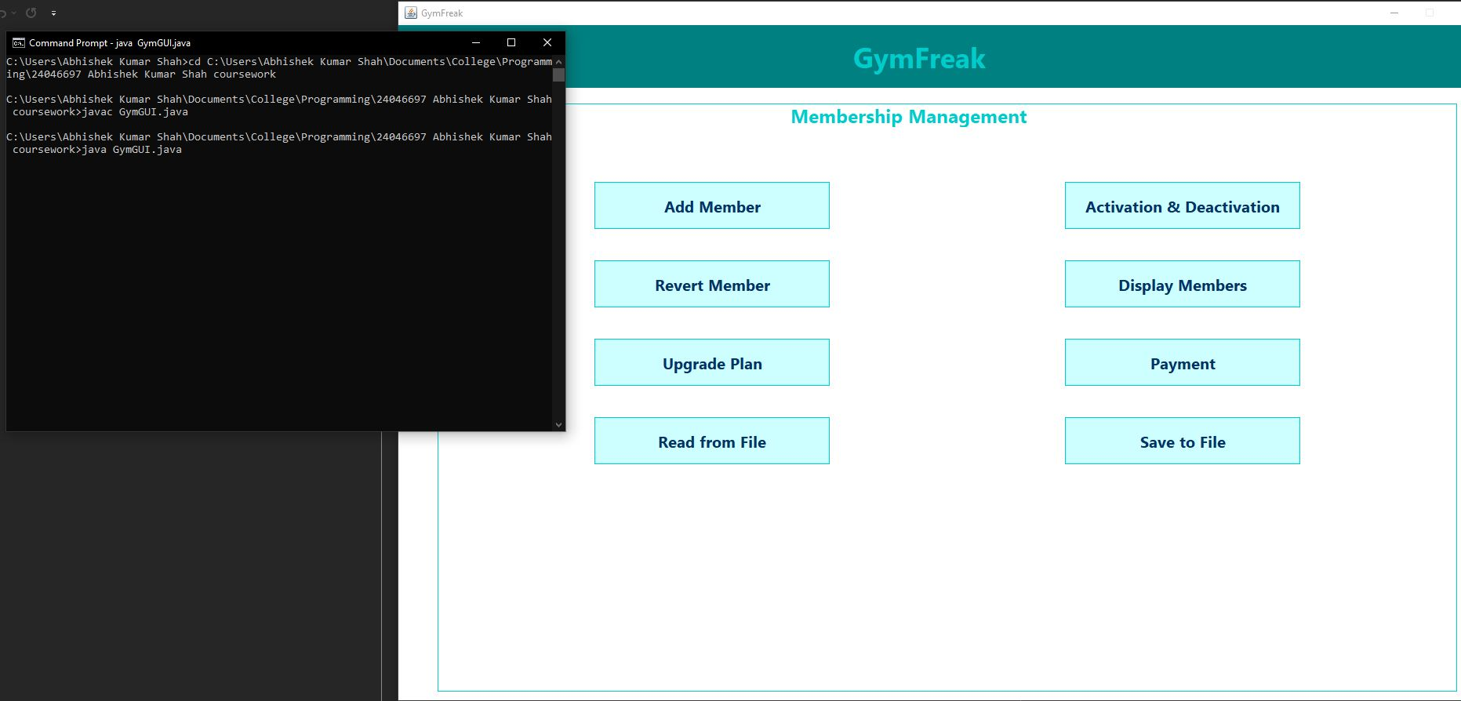

Figure 16: Test 1-Compile and run using command prompt/terminal

## Test-2: Add regular and premium members

Table 2: Test 2

|  |  |
| --- | --- |
| Objective | To verify if new Regular and Premium members can be added through the interface. |
| Action | Used the "Add Member" feature to register both a Regular Member (with referral and plan) and a Premium Member (with trainer). |
| Expected Result | Member details should be validated and added to the internal list. No errors for valid inputs. |
| Actual Result | Both members were successfully added. Invalid inputs triggered appropriate error messages. |
| Conclusion | Passed-Member registration logic works correctly and handles both valid and invalid input scenarios. |

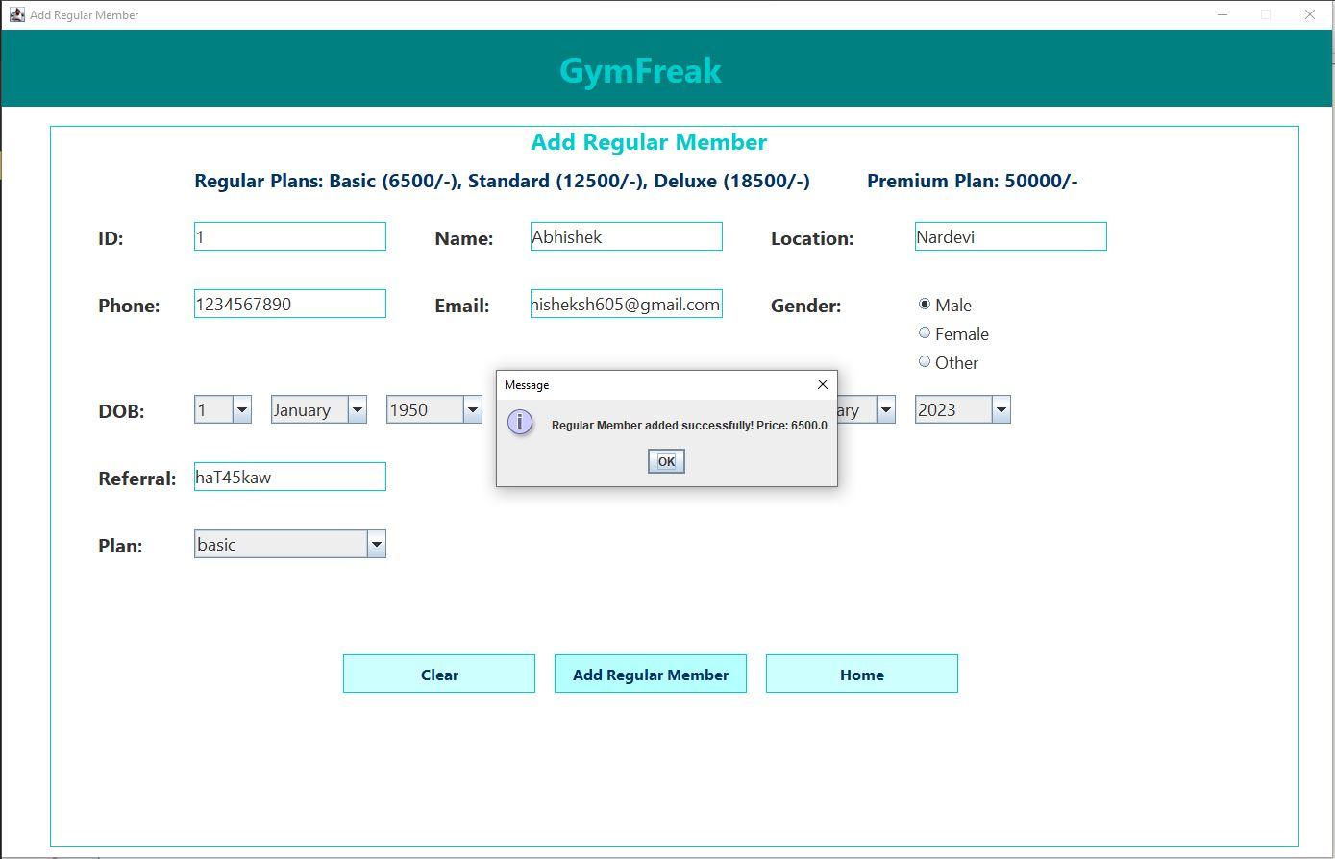

Figure 17: test 2.1-add regular member

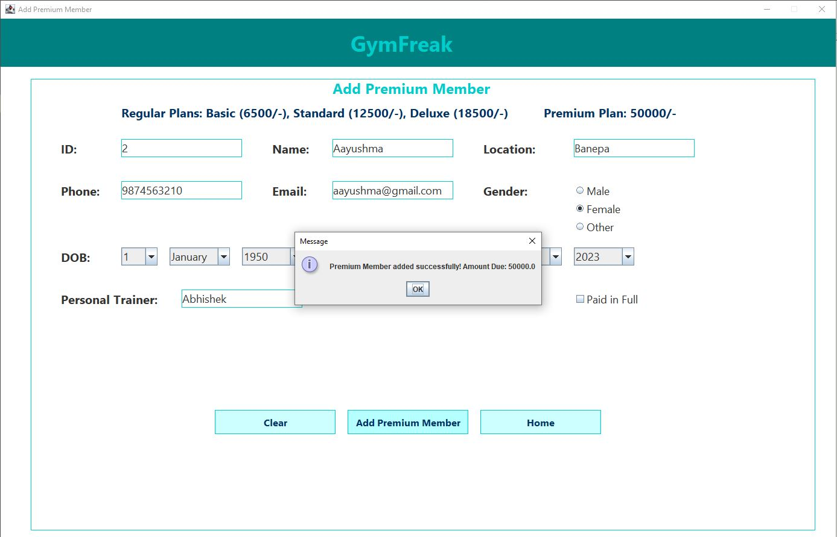

Figure 18:test 2.2- add premium member

## Test-3: Mark attendance and upgrade plan

Table 3: Test 3

|  |  |
| --- | --- |
| Objective | To confirm attendance tracking and plan upgrade functionality works for eligible Regular Members. |
| Action | Marked attendance for a Regular Member until they reached the required loyalty points. Then attempted a plan upgrade. |
| Expected Result | Loyalty points should increase, and plan upgrade should only be allowed if criteria are met. |
| Actual Result | Attendance incremented loyalty points accurately. Plan upgraded successfully when eligibility was met. |
| Conclusion | Passed-Both attendance marking and upgrade plan features function as designed and respect logical conditions. |

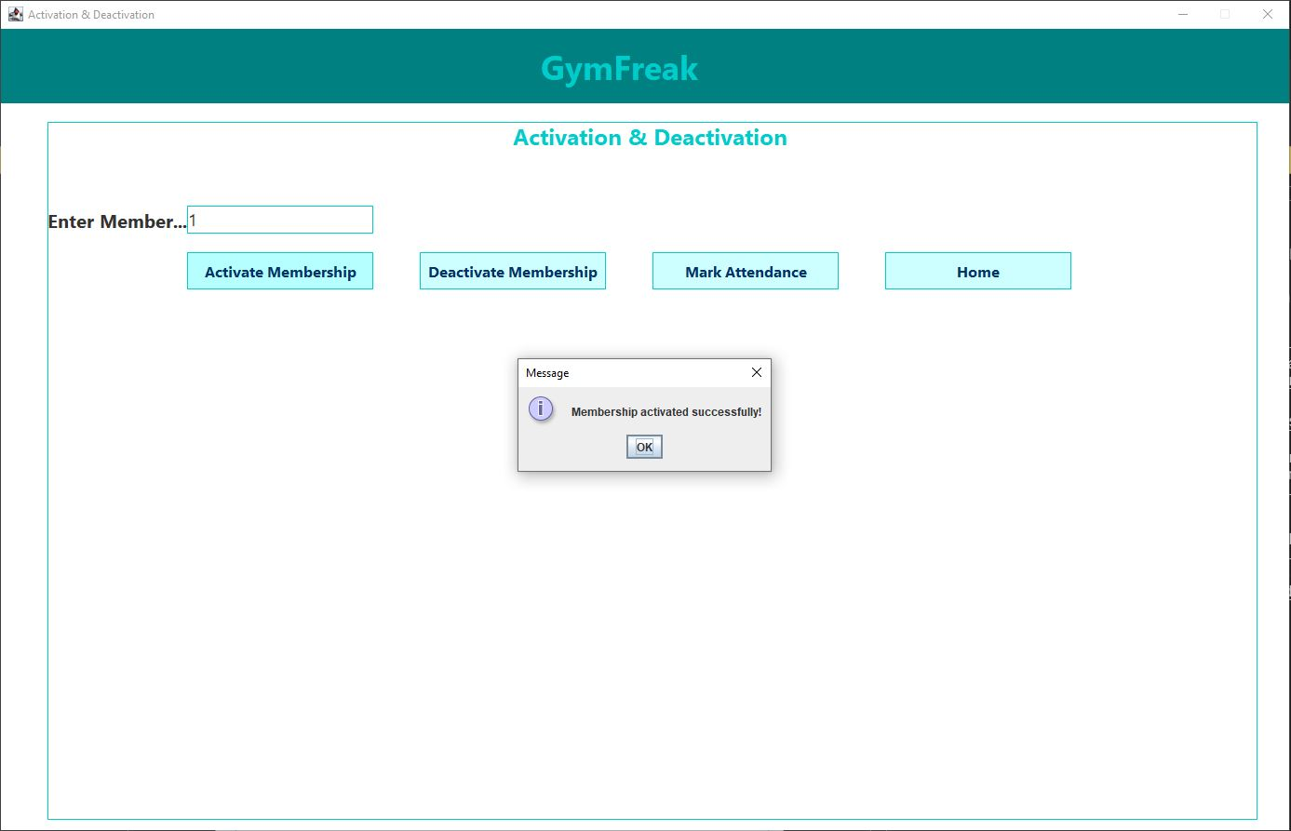

Figure 19: test 3.1- activating membership

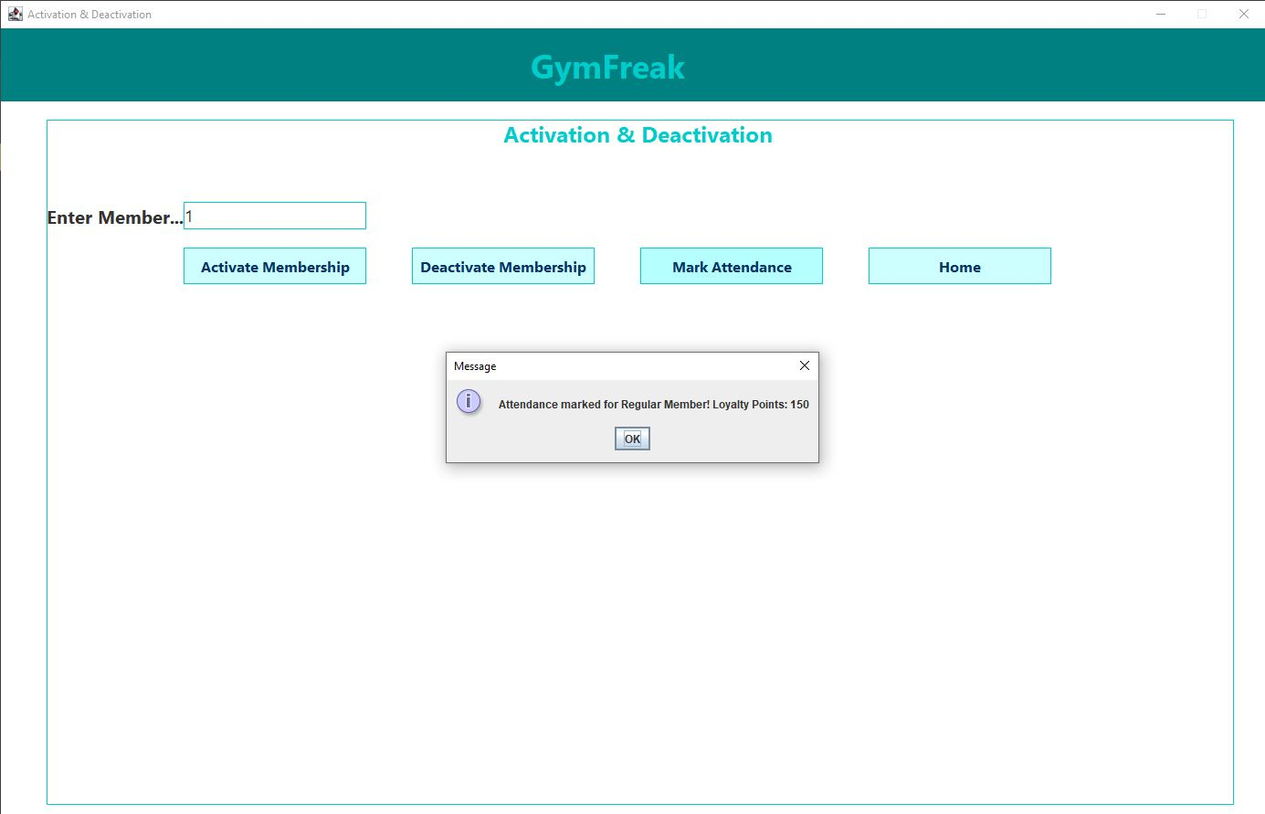

Figure 20: test 3.2- marked attendance 30 times to meet loyalty points at 150

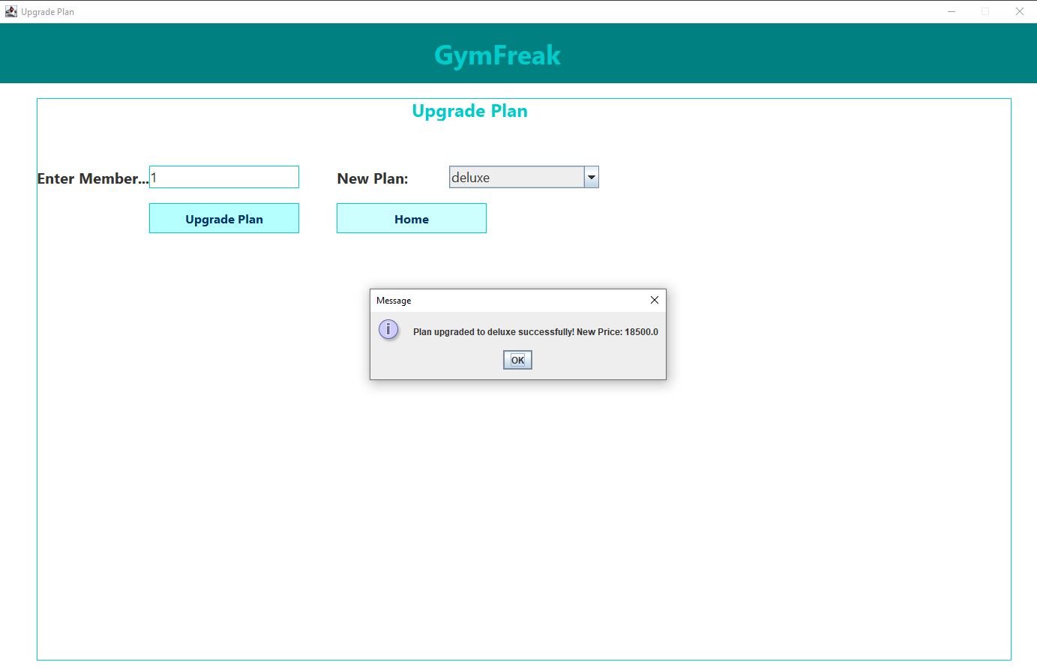

Figure 21: test 3.3-plan was upgraded to deluxe

## Test-4: Calculate discount, pay due, revert members

Table 4: Test 4

|  |  |
| --- | --- |
| Objective | To evaluate payment processing, discount application for Premium Members, and the ability to revert members. |
| Action | Processed a payment for a Premium Member with a discount. Then used the revert option for both member types. |
| Expected Result | The system should calculate the correct payable amount after discount, update payment status, and reset fields on reversion. |
| Actual Result | Payment calculations and discount logic were accurate. Revert functionality reset member states and stored the removal reason. |
| Conclusion | Passed-discount, pay due and revert members functions are behaving reliably with proper validation. |

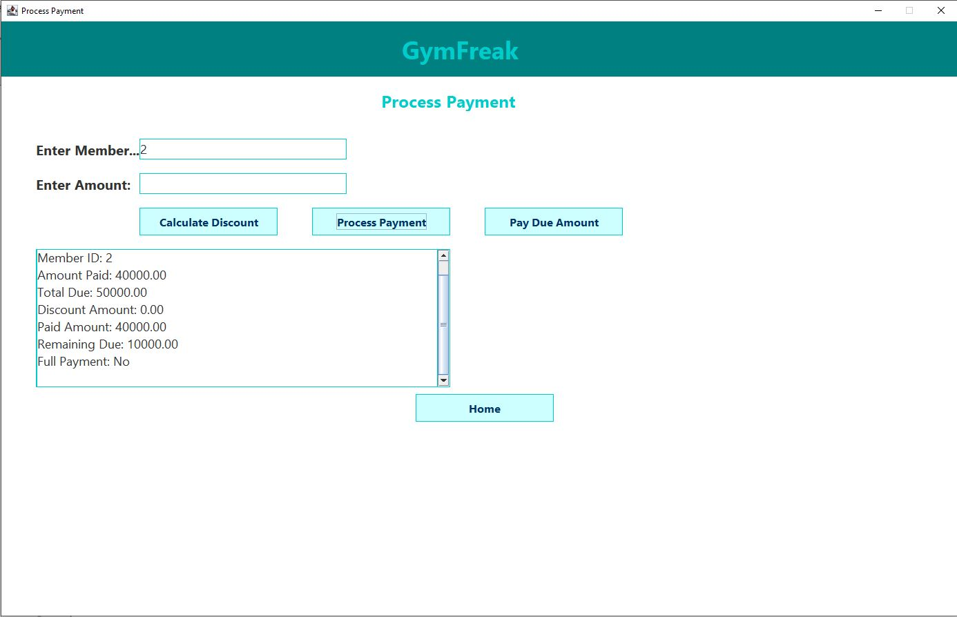

Figure 22: test4.1-Payment processed

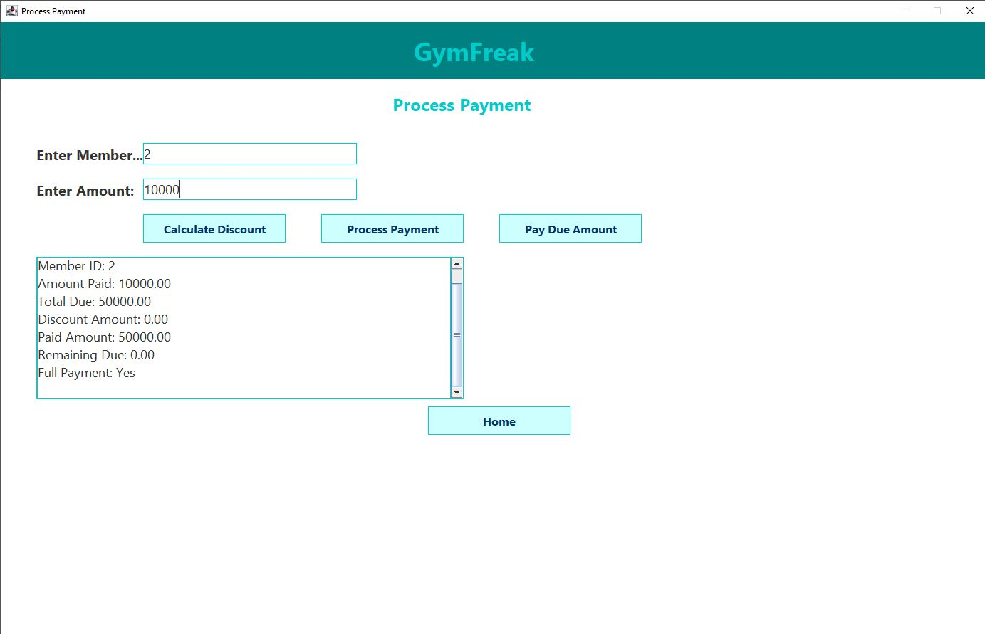

Figure 23: test 4.2-paid due amount

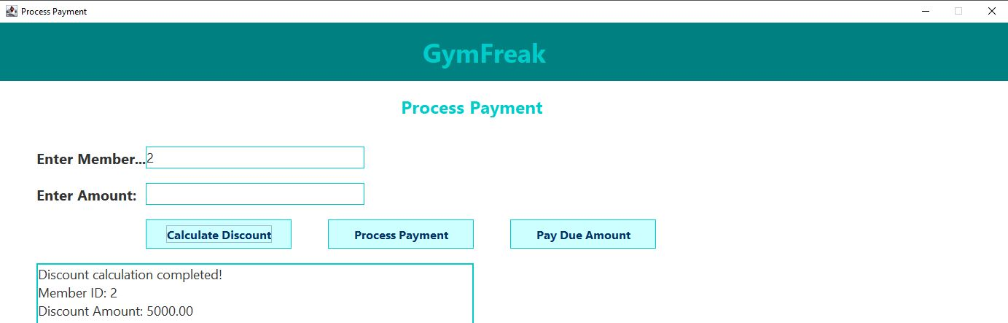

Figure 24:test 4.3 calculate discount

## Test-5: Save to and read from file

Table 5: Test 5

|  |  |
| --- | --- |
| Objective | To validate that member data can be stored and retrieved from a file. |
| Action | Used "Save to file" to write member info to a text file, then clicked "Read from file" to display contents. |
| Expected Result | The saved file should contain formatted member data. Reading should retrieve and display this information. |
| Actual Result | Member data was successfully saved and correctly displayed when read back into the system. |
| Conclusion | Passed-File handling is operational. Save to file and Read from file are storing and retrieving data as expected. |

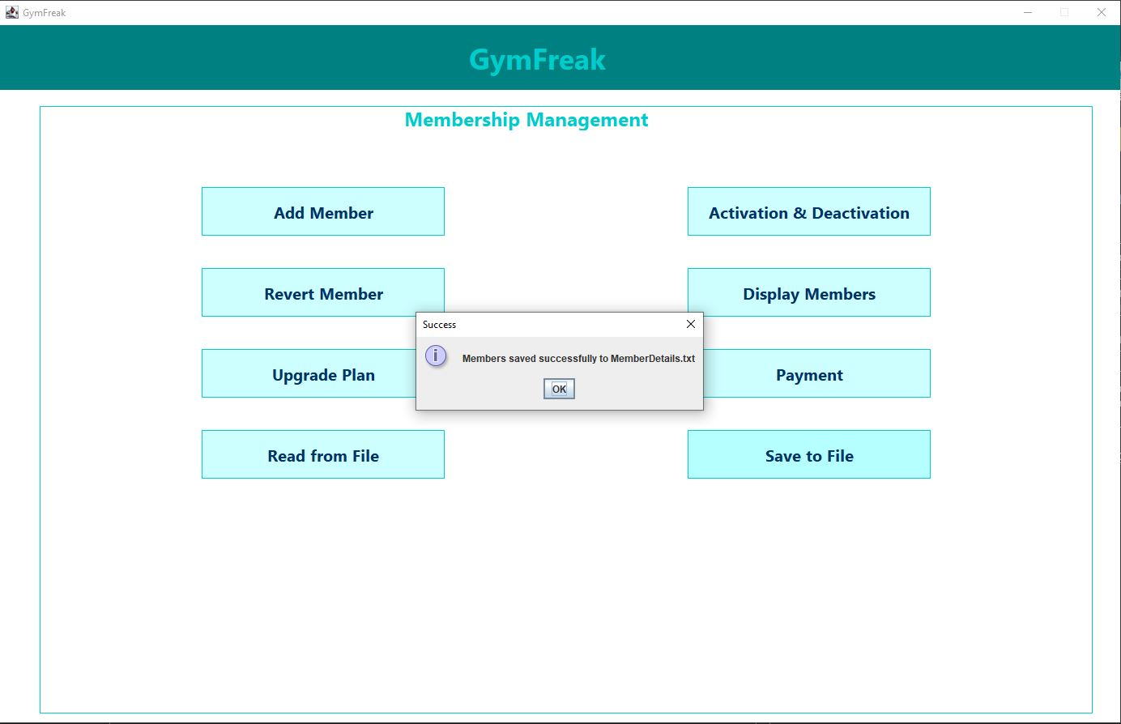

Figure 25: test 5.1- save to file

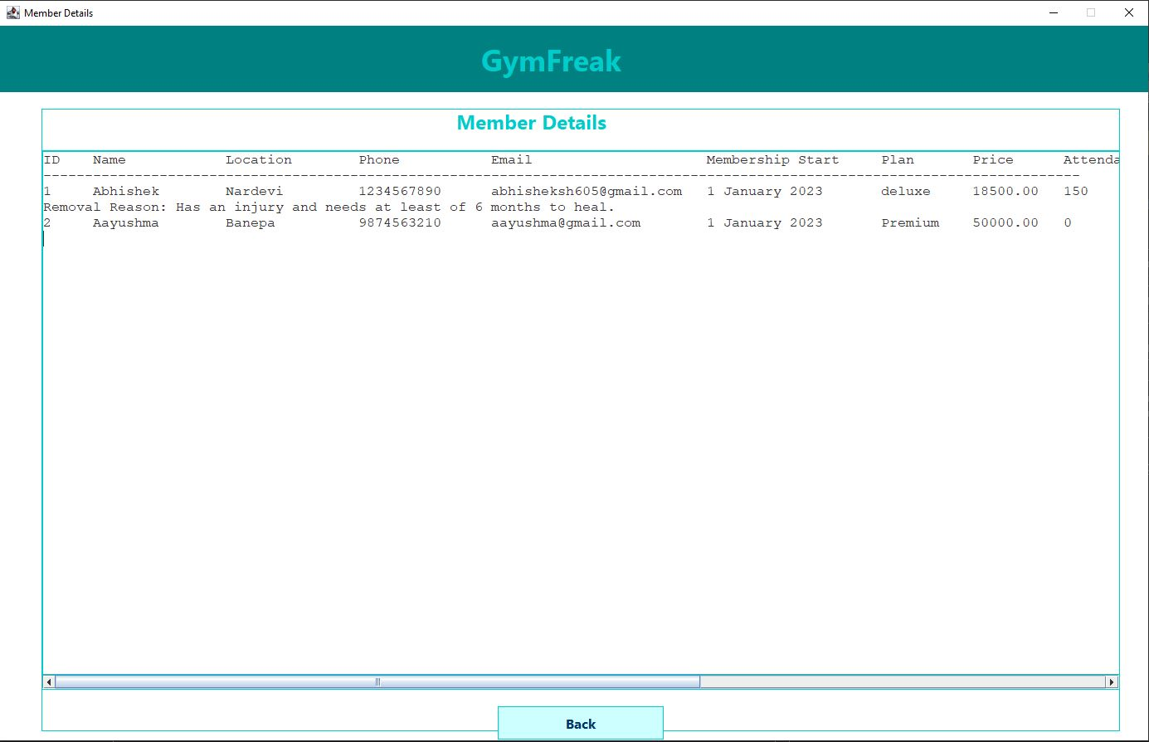

Figure 26: test 5.2- read from file

# **Error and Detection**

## Syntax error

Syntax errors occur when the code doesn’t follow the rules of the Java language. These are usually highlighted during compilation.

**Example Encountered:**  
I forgot to add semicolons at the end of statements .

**How I Fixed It:**  
I used the compiler’s error messages to find the exact line causing the problem. In most cases, it pointed me straight to the missing or incorrect symbol, and I corrected it accordingly.   
  
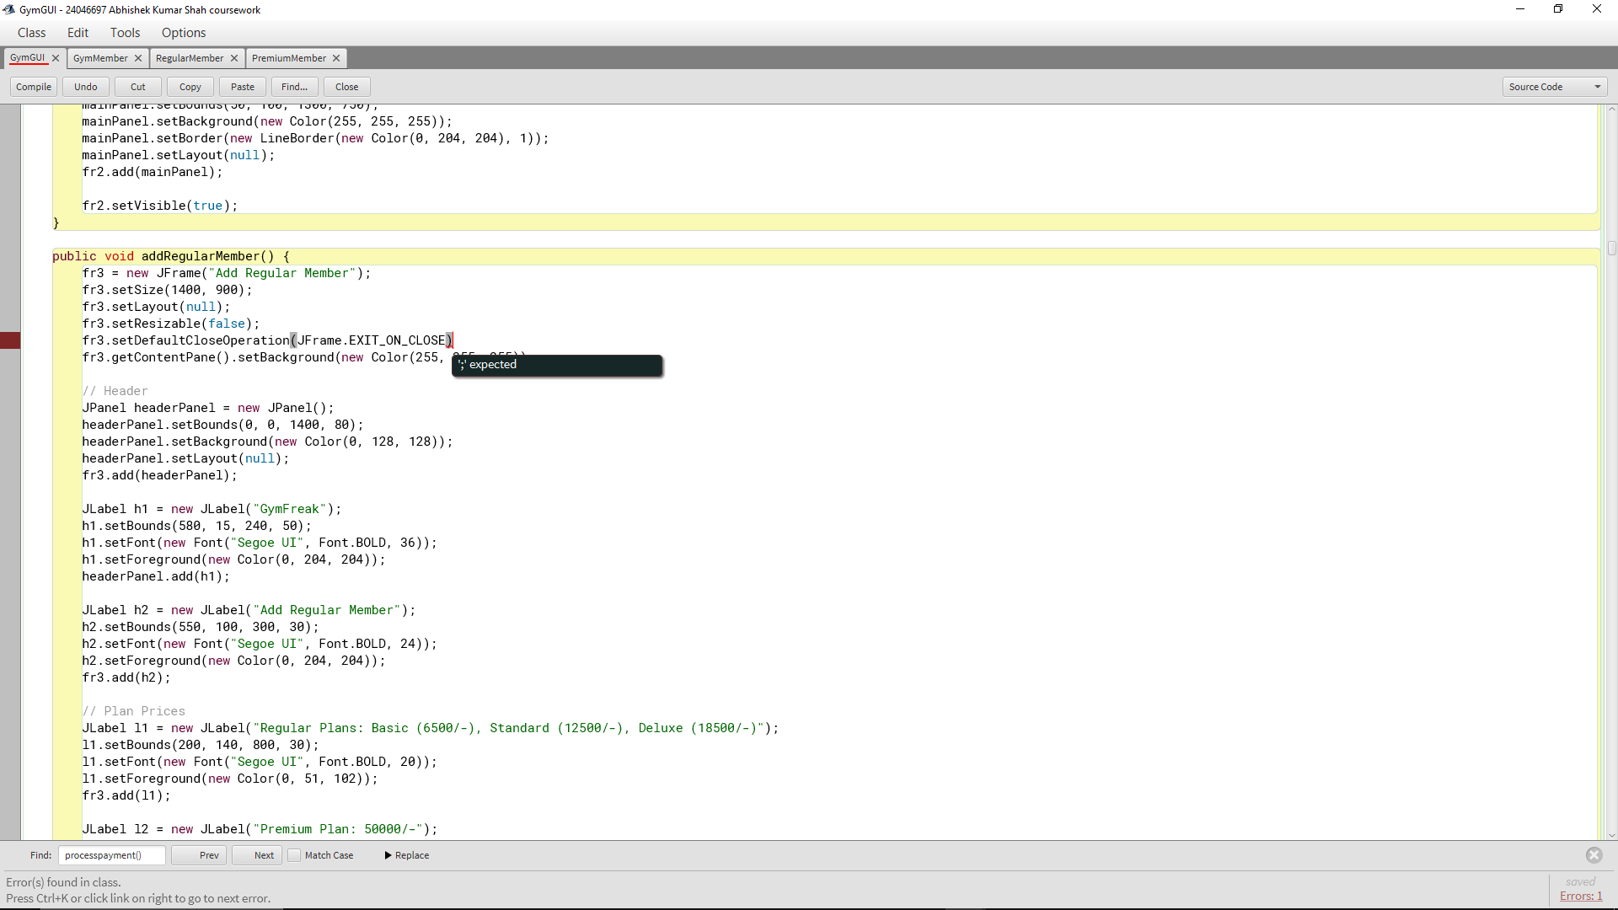

Figure 27: syntax error example

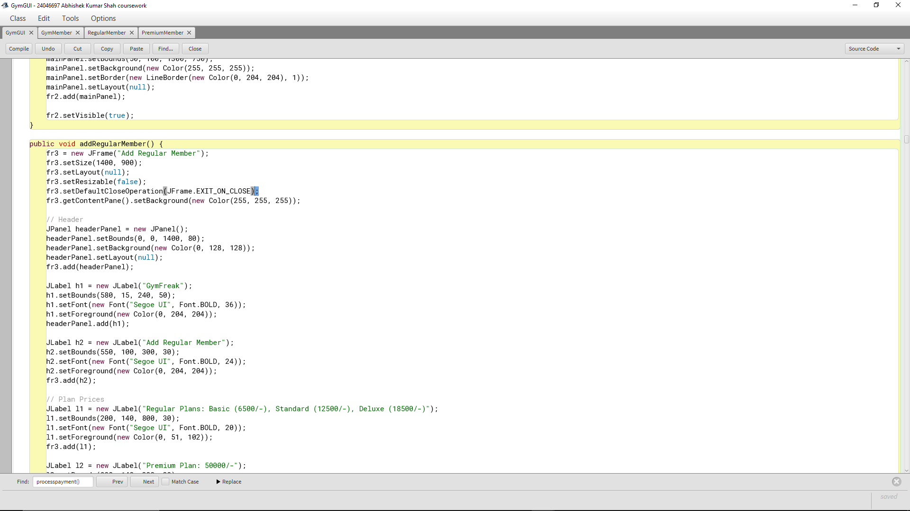

Figure 28: fixed syntax error

## Runtime Error

Runtime errors are problems that occur while the program is running. They don’t stop the code from compiling but can cause the program to crash when executed.

**Example Encountered:**  
I removed a try-catch block from the file reading method to test something. When I ran the program without it, it crashed immediately because the file MemberDetails.txt didn’t exist yet. Java threw a FileNotFoundException.

**How I Fixed It:**  
I added the try-catch block back and used it to catch the exception. I also included a simple error message using JOptionPane so that users are informed if the file is missing or empty instead of the program crashing.

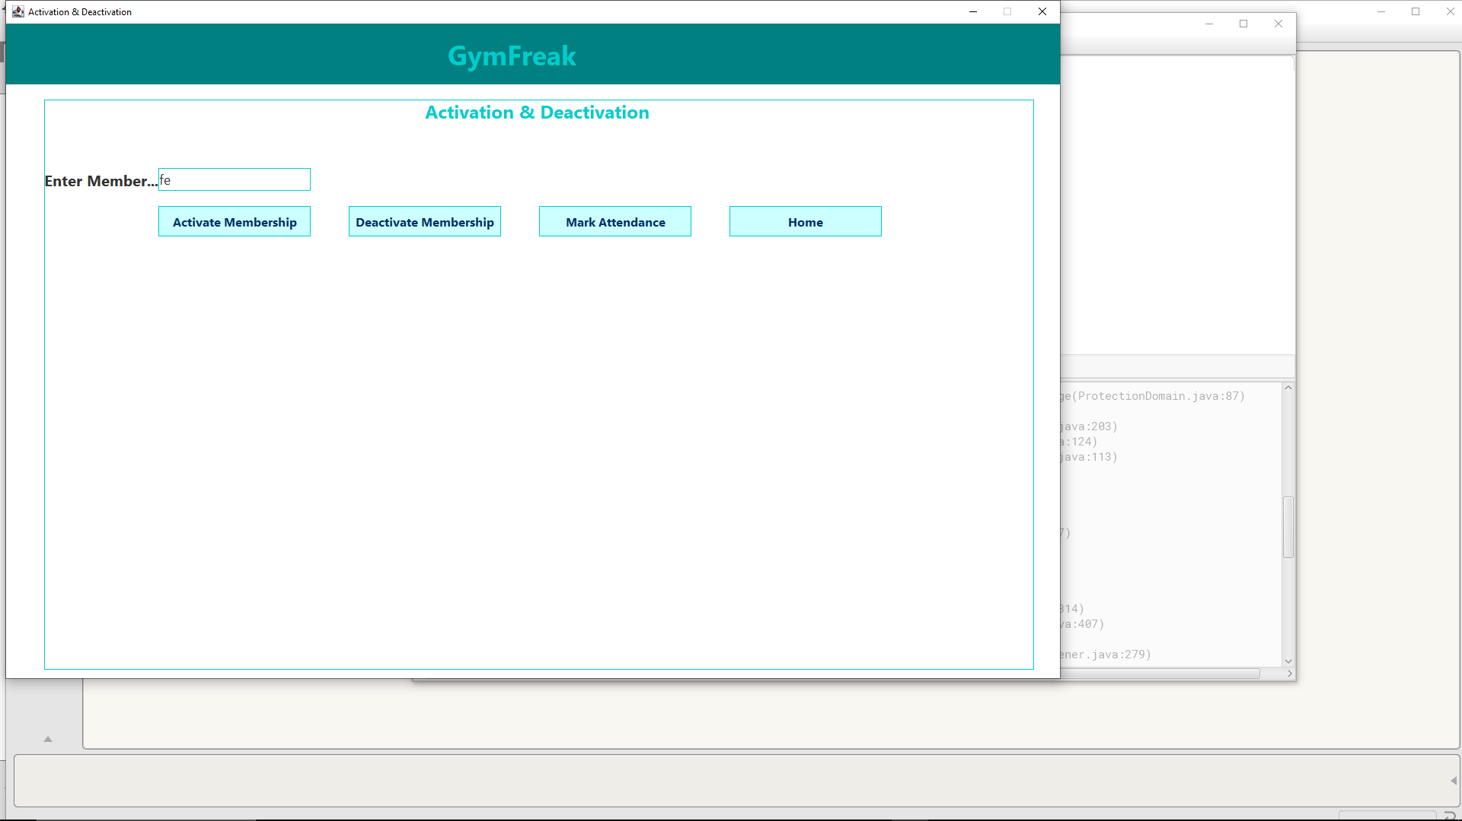

Figure 29: runtime error 1.1

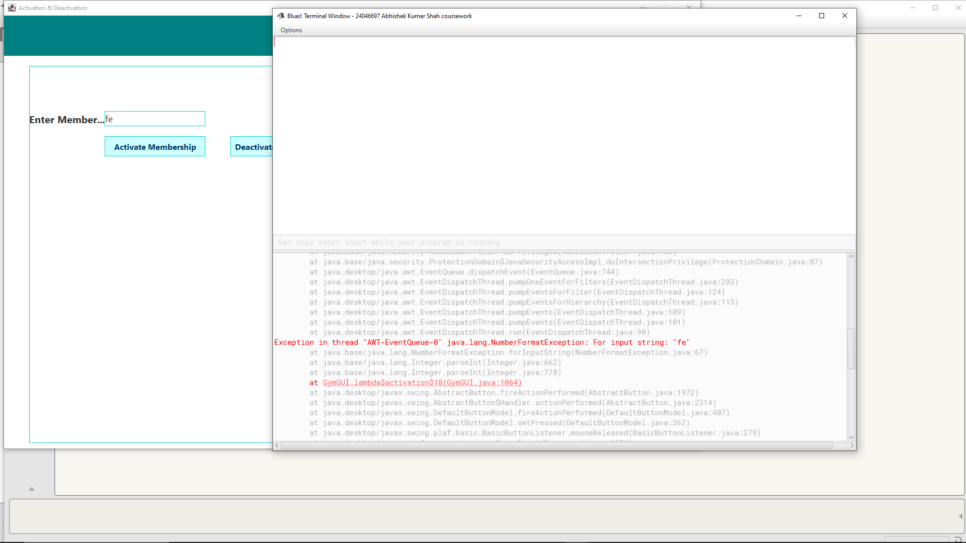

Figure 30: run time error 1.2

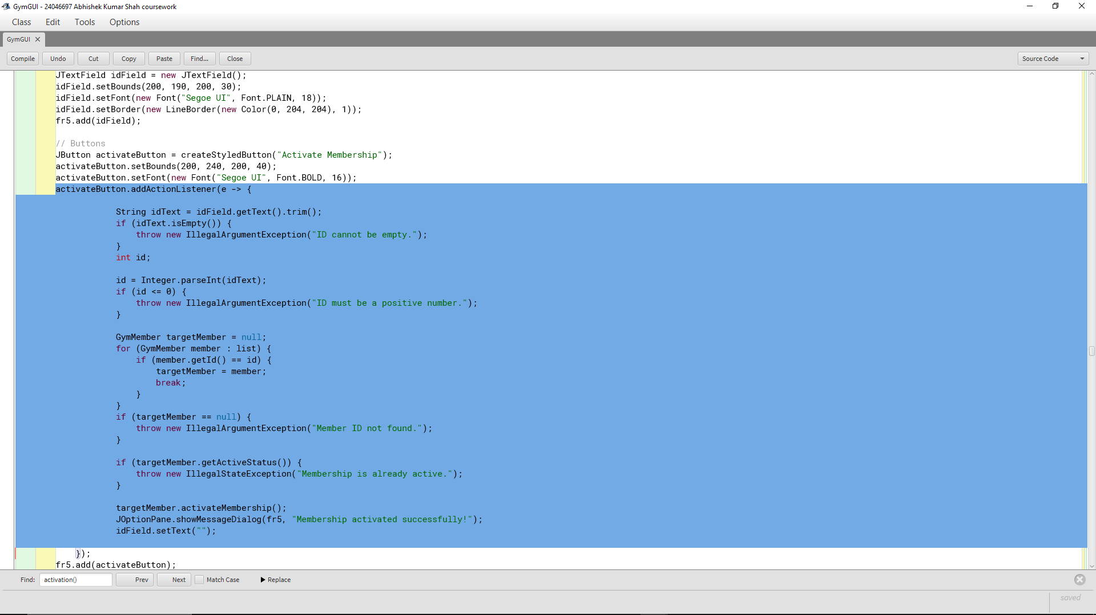

Figure 31: run time error 1.3

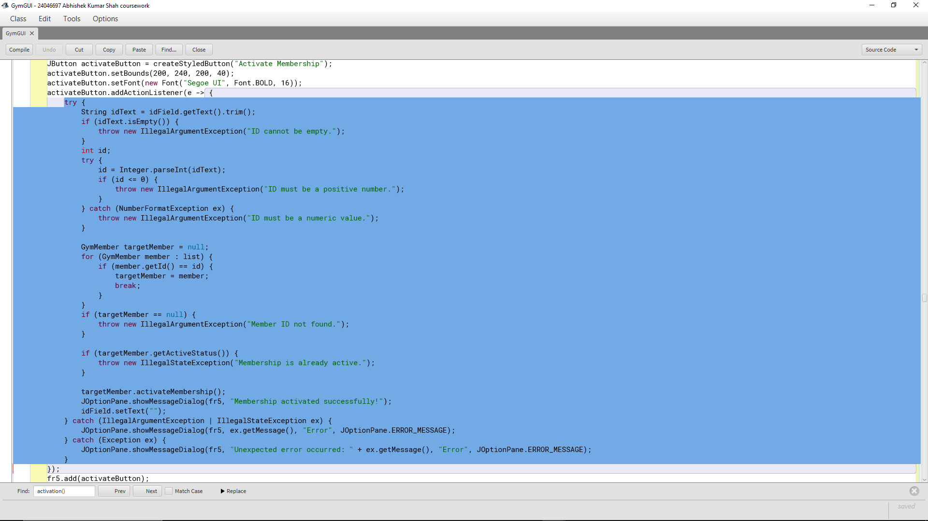

Figure 32: runtime error 1.4

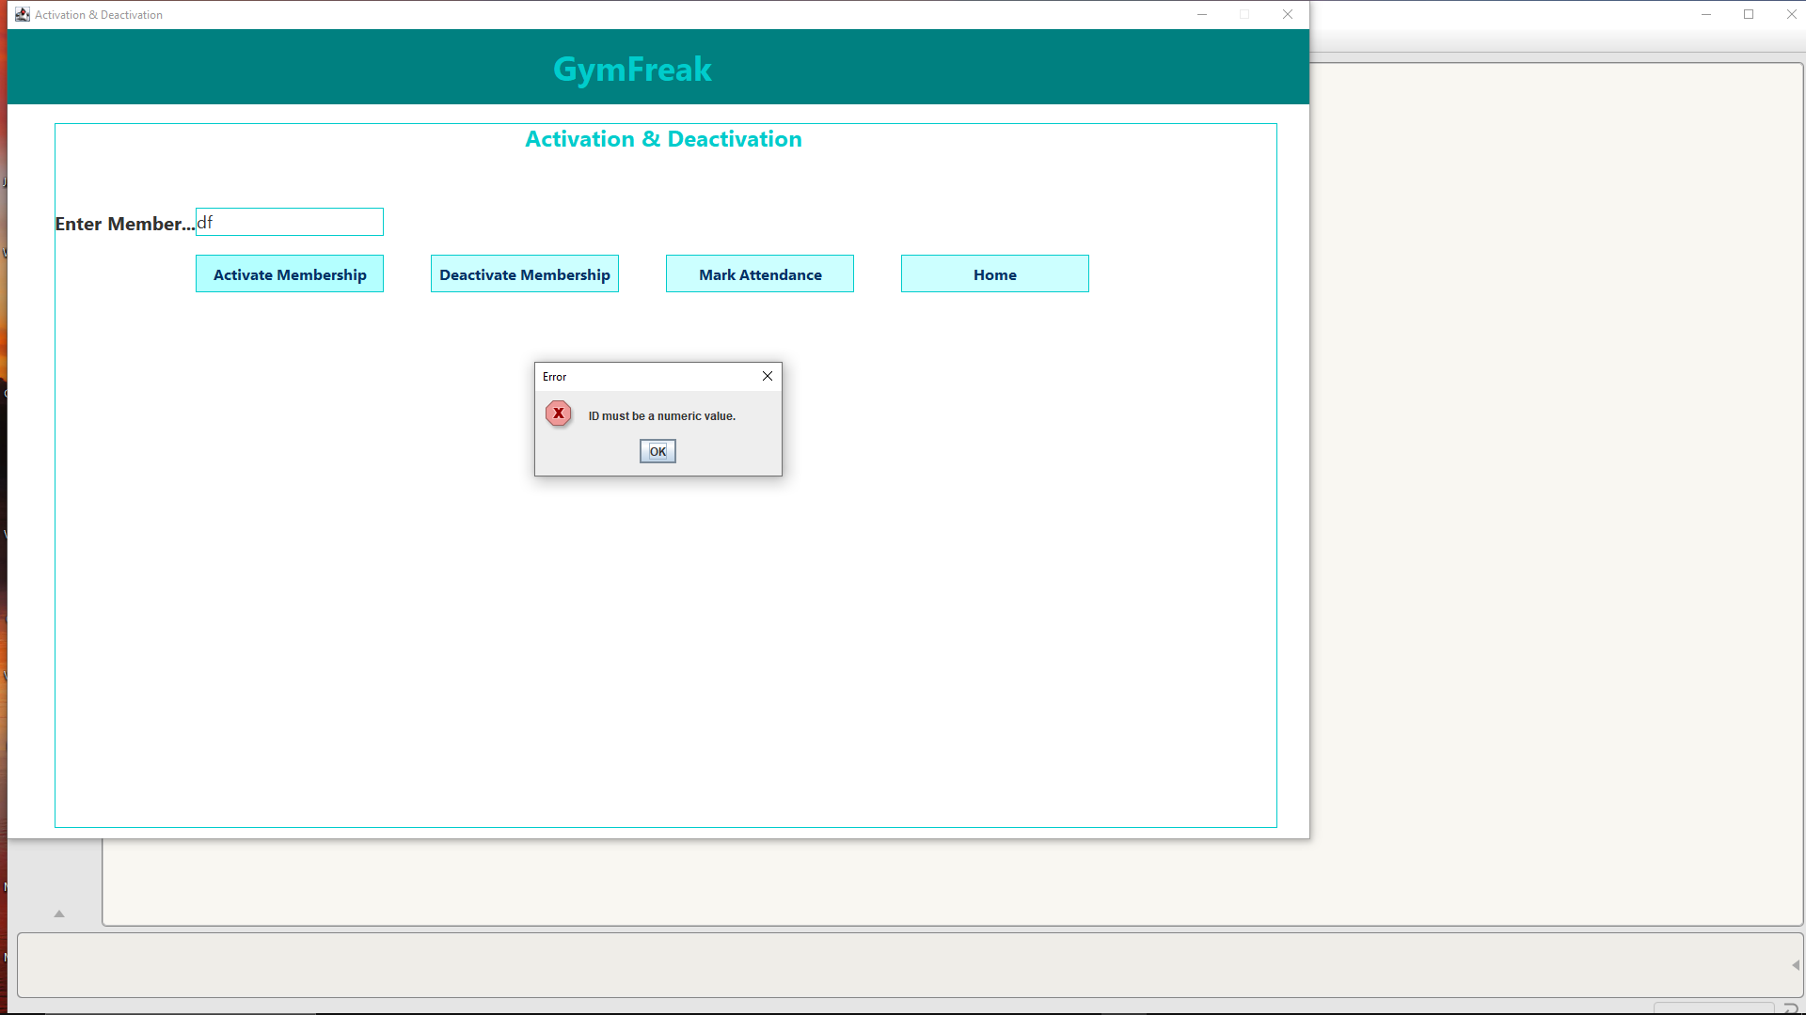

Figure 33: run time error 1.5

## Logical Error

Logical errors occur when the program runs without crashing but doesn't behave the way it should because the logic is incorrect.

**Example Encountered:**  
I initially allowed Regular Members to upgrade plans even if their loyalty points were below the required limit, due to a mistake in the condition used.

**How I Fixed It:**  
I reviewed the if conditions and compared them with the project requirements. By testing the feature with different loyalty points, I realized the mistake and corrected the logic to check for at least 150 points before allowing an upgrade.

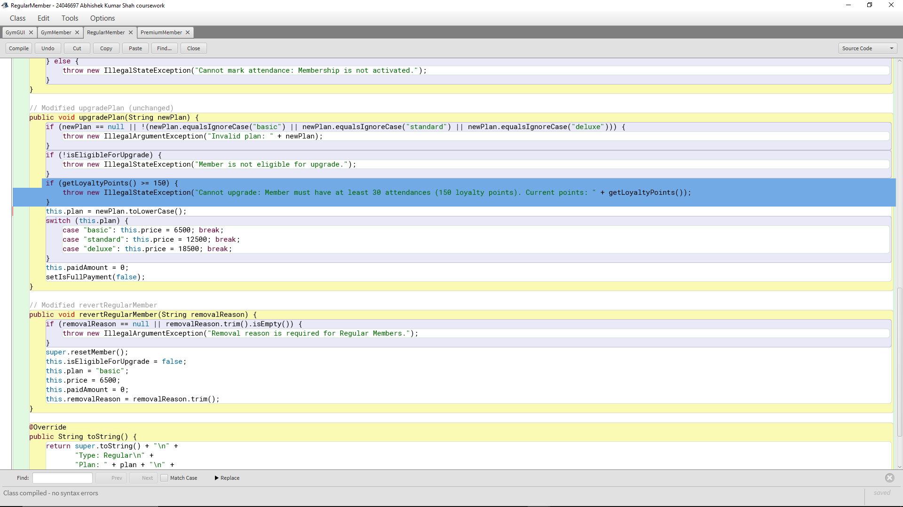

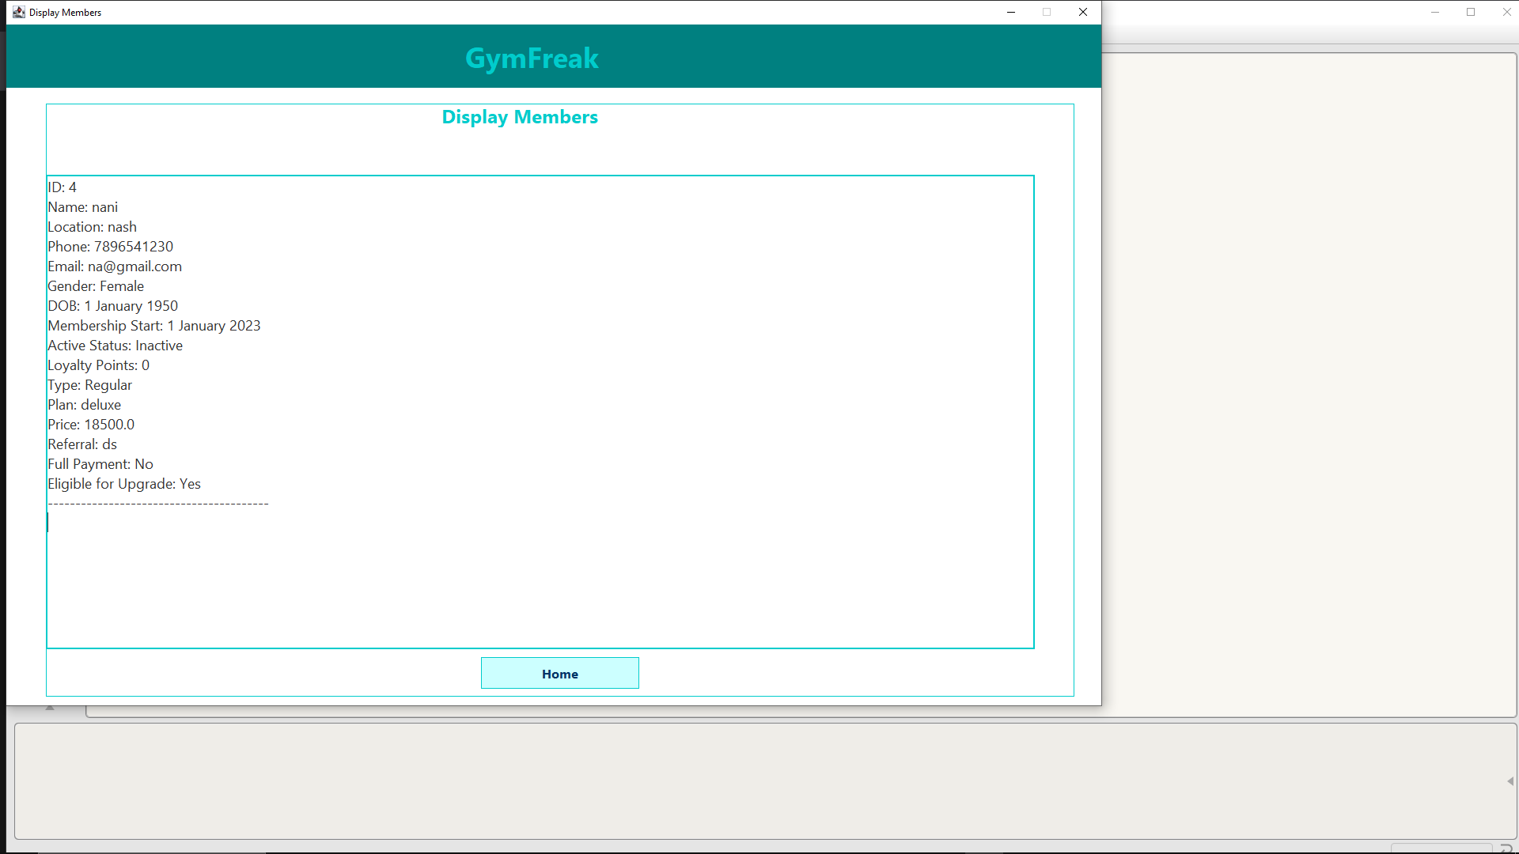

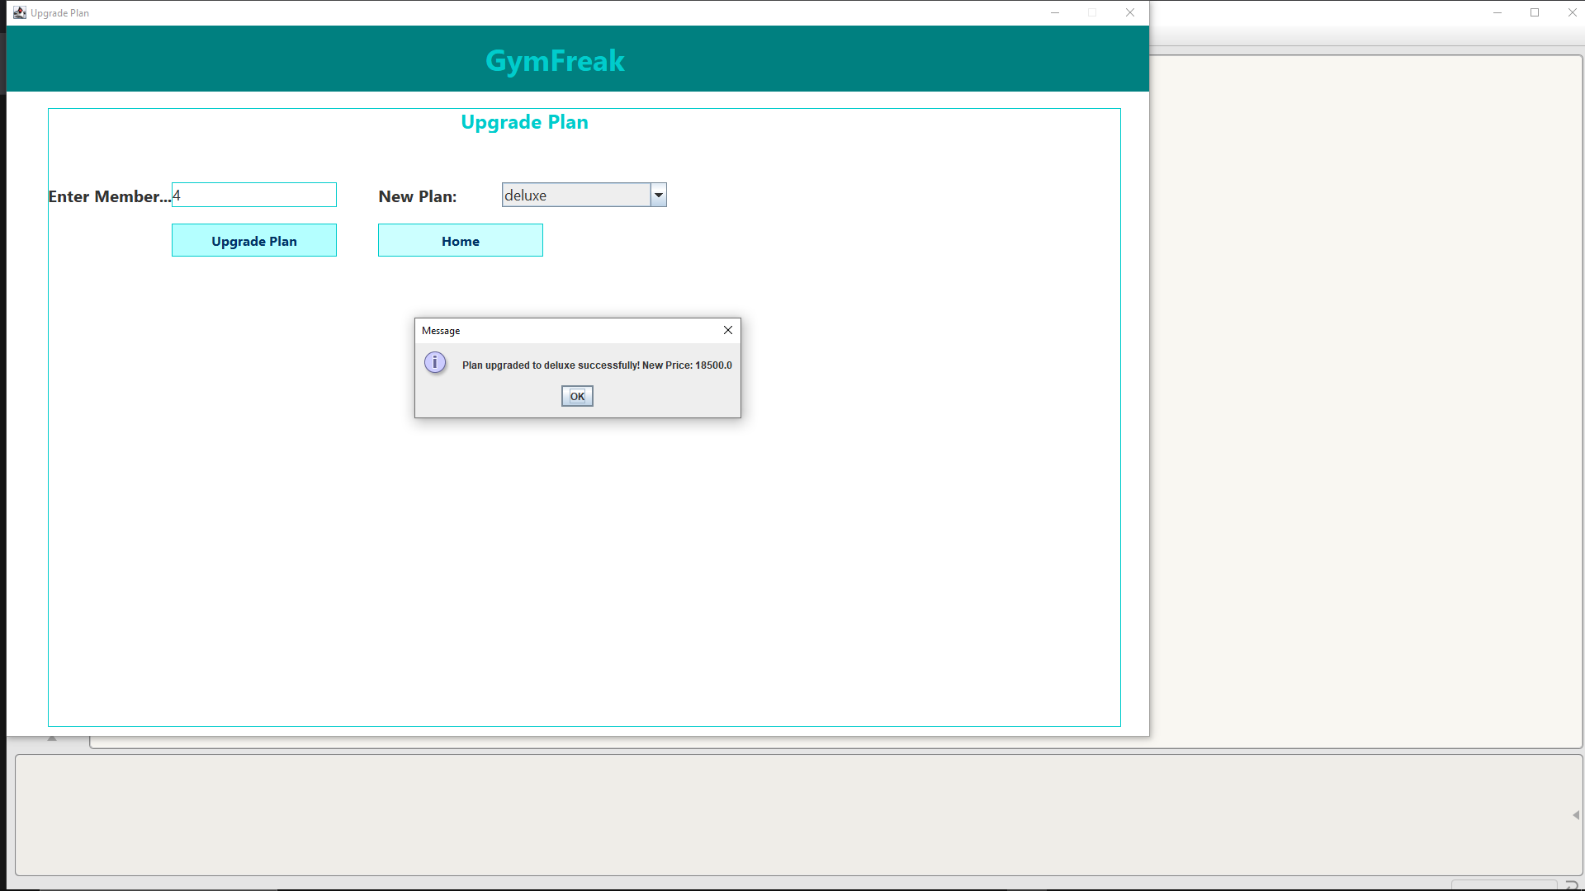

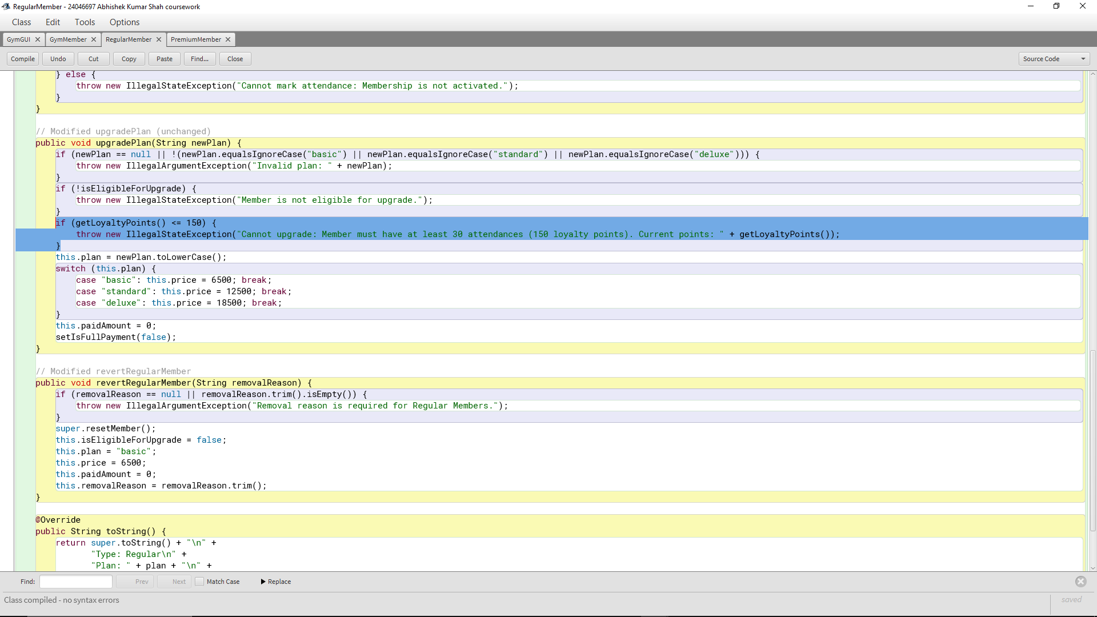

# **Conclusion**

This Gym Management System was a major project that allowed me to apply Java programming skills in a practical way. The application helps manage gym members, both regular and premium, through a user-friendly graphical interface. Users can register new members, manage their membership status, record attendance, handle payments, and store or retrieve data using a text file. The project includes several features commonly needed in real-world systems, and I was able to complete all the main parts successfully.

The system performs the key tasks as intended. I was able to add regular and premium members with proper checks, such as making sure the ID is unique and the phone number has exactly 10 digits. Regular members can upgrade their plans based on how active they are, and premium members can get discounts. I also built features to mark attendance, track loyalty points, and revert members if needed. The save and load functions work smoothly, allowing data to be stored in a file and loaded back later.

The graphical interface, built using Java Swing, is organized into different windows where users can choose what they want to do—like add a member or handle payments. Each part of the program works together to make managing the gym simple and efficient.

Working on this project helped me improve my understanding of object-oriented programming, especially the use of classes, inheritance, and methods. I learned how to create a base class (GymMember) with shared attributes and then extend it to make RegularMember and PremiumMember with their own specific features. This made the code easier to manage and update.

I also got better at designing user interfaces with Swing. I learned how to add buttons, input fields, and menus, and how to switch between different screens based on user actions. Writing clear and organized code became easier as I practiced building and linking different parts of the program.

Another big learning area was validating user input. I had to make sure users enter correct data, like valid phone numbers or proper email addresses, and give clear error messages when something is wrong. I also got more confident using files to save and load data, which taught me how to work with text files in Java.

There were a few problems I ran into, especially with the interface. Switching between windows was confusing at first. Sometimes multiple screens would stay open or not respond properly. I fixed this by making sure to close the current screen before opening the next one.

I also had some trouble with input validation. At first, the program didn’t catch things like duplicate IDs or incorrect phone numbers. I solved this by adding extra checks in the code and using pop-up messages to inform the user when input was wrong.

Another tricky part was handling payments, especially applying discounts for premium members and making sure the full amount was updated correctly. I had to carefully test different situations to make sure everything added up and the payment status changed at the right time.

Saving and reading from the file was also a bit hard. I had to make sure the formatting was readable and that the program didn’t crash if the file was missing or empty. I added checks to prevent errors and give useful messages instead.

I also created a testing plan that helped me make sure everything worked step-by-step. By going through the features one at a time—like adding members, marking attendance, making payments, and saving to file—I could catch and fix problems early.

This project helped me grow a lot as a Java programmer. I’m proud of how far I’ve come—from setting up the basic structure to adding full functionality with a user interface. I now feel more confident in handling real-world problems using Java. If I continue working on this project, I’d like to improve the visual design and maybe connect it to a database instead of a text file.

Overall, building this gym management system was a challenging but rewarding experience that taught me valuable skills I can use in future projects.